|  |  |  |
| --- | --- | --- |
|  | **CAN THO UNIVERSITY SOFTWARE CENTER** |  |
| **MEKONG DELTA - APTECH** |

**SEMESTER PROJECT – III**

**ONLINE FLORAL DELIVERY**

|  |  |
| --- | --- |
| **Instructor:** | **Class:** CP2096G01 |
| Ms. Linh Ong Thi My | **Team:** 3 |
|  | **Students:** |
| Student1138899 – Nguyen Tran Ngoc  Student1138913 – Dat Quang Tan  Student1146945 – Em Tran Mot  Student1138942 – Loc Vo Hien |

Can Tho, 10/2020

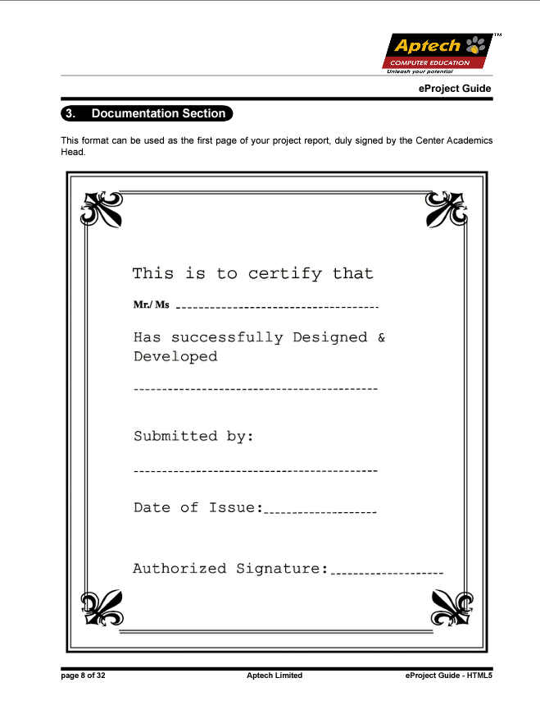

1. **Problem Definition:**

Java Florist is a professionally designed flower arrangement service provider for all occasions such as birthday, wedding, new baby, thank you, fathers day, mothers day, ... Flower arrangements are becoming more and more popular. It has connected with thousands of families and has succeeded in conveying deeply meaningful wishes through sending flowers. Due to increasing demand from customers and Java Florist wants to help everyone communicate those wishes by sending bouquets of flowers on a special occasion in the most convenient way. They decided to develop a website to cater to customers in Mumbai and the surrounding area and could even deliver flowers nationwide through a network of trusted florists. Thanks to that, customers can easily choose the appropriate bouquets and wishes to order and send to their loved ones. The manager also easily manages their bouquets, invoices, and loyal customers quickly and conveniently, ... Besides, it also contributes to the development of the system, bringing high economic value, efficient business.

1. **Customer Requirement Specification(CRS):**

**Client:** Java Florist.

**Business/Project Objective:**

* Provide Java Florist with a website that can help people communicate their wishes by sending bouquets of flowers on special occasions.
* Solve and fix the problems they encounter.
* Helping employees to easily manage the products.
* Customers easily search for products with different special occasions.
* Customers order and buy goods quickly and conveniently.
* Increase efficiency and save management time.

**Inputs provided by the client:**

* Inputs to the existing system:
* Customer: Customer ID, Password, First Name, Last Name, Date of Birth, Gender, Phone, Address, Status.
* Employee: Employee ID, Password, First Name, Last Name, Date of Birth, Gender, Phone, Adress, Role, Status.
* Flower: Flower ID, Supplier ID, Flower Name, Short Description, Meaning.
* Bouquet: Bouquet ID, BouquetName, Flower ID, Occasion ID, Sale ID, Main Image, Unit Price, Old Unit Price, Short Description, Description, Quantity, Status.
* Bouquet Image: Image ID, Image File Name, Bouquet ID.
* Occasion: Occasion ID, Occasion Name.
* Message: Message ID, Occasion ID, Message Content.
* Payment: Payment ID, Payment Name.
* Order: Order ID, Customer ID, Payment ID, Message, Creation Date, Name of recipient, Address of Recipient, Phone of recipient, Shipping Date, Note, Status.
* Order Detail: Order ID, Bouquet ID, Unit Price, Quantity.
* Comment: Comment ID, Content, Comment Date, Bouquet ID, Customer ID.
* Supplier: Supplier ID, Supplier Name, Contact Name, Phone, Email, Address.
* Sale: Sale ID, Sale Name, Content, Start Date, End Date, Picture, Discount.
* Blog Categories: Blog Categories ID, Name.
* Blog: Blog ID, Blog Name, Employee ID, Content, Date, Picture, Blog Category ID.
* Blog Comment: BlogComent ID, Name, Content, Date, Email, Blog ID.
* Outputs from the existing system:
* Home page: logo, menu
* Information about customers (Personal , Orders, Order Details)
* Information about staffs.
* List of bouquets, flower types, occasions, messages, promotions, vendors, comments, invoices, customers, employees, blogs, importation, exportation.
* Statistics and reports on bouquets, bouquet types, occasions, messages, promotions, vendors, comments, invoices, customers, employees, blogs, importation, exportation.
* Process involved in the application:
* Admin.
  + Log in, Log out.
  + Manage customers information.
  + Update, delete data and add new details (Manage Bouquets, Flowers, Orders, Invoices, Good in Stock, Employees, Occasions Information, Blogs).
  + Manage and export reports
* Customer
  + Log in, Log out.
  + Registration.
  + Modify Personal Information.
  + Online purchase: They can purchase flowes, bouquets online in website and pay by internet banking.
  + Feedback: They can write their personal comments about products, website, delivery, etc.
  + View orders status, invoices details, delivery status, transaction history.
  + View new blogs.
  + Receive notify about new products, new sales.
* Website
  + Some new blogs, new sales, popular flowes, bouquet will be state in the Home Page.
  + Home Page will be design with an introduction to the site and all the navigation links available.
  + Upcoming activities will be flash in the Home Page.
  + Contact us: It displays the details of the contact
  + About us: It displays the details of the florist.
* Expected delivery dates: 02-November-2020.
* List of deliverables:
* Source code
* Database
* Documentation
* Table of Contents
* Problem Definition
* Customer Requirement Specification
* Architecture and Design of the Project
* Flow chart
* Data Flow Diagram
* Entity Relationship Diagram
* Database Design
* Task Sheet
* Checklist of Validations
* Submission Checklist
* Helps
* User Guide
* Installation Guide
* Developer’s Guide

**Hardware Requirements:**

* *Server*:
* Intel Core i5-5200U, 2.5GHz
* RAM 4GB, HDD 500GB Storage
* Dedicated server or Dedicated Virtual Server Environment
* *Client*:
* CPU i3 3.0Ghz or more
* Ram 2GB or more
* HDD 80GB

**Software Requirements:**

* *Server*:
* SQL Server 2017 (or higher)
* .Net Framework 4.7.2, IIS Server, IIS SMTP Service,…
* *Client*:
* Web browser:
* Chrome 4.0 or higher.
* Internet Explorer/Edge 9.0 or higher.
* Firefox 3.5 or higher.
* Safari 4.0 or higher.
* Opera 10.5 or higher.

**Scope of the Work (in brief):**

1. The application will have a web page  which have links or option home, My account, about flowers, view cart, ,florist registration etc.
2. the home page will also have link for different occasions and when the user clicks on any occasion the  bouquets available with that occasion would  be displayed with there price.
3. If the user wants to book any bouquets he has to register himself. At a time the user can book more than one bouquets. At the time of booking the bouquets gets attached to cart and the total price will be calculated.
4. The price would be paid through credit card.
5. After paying the money  it should also collect the information to whom the bouquet have to be delivered, their name, address, phone no and the message.
6. For messages there would be dropdown list having all the occasion in the list. According to the selected occasion predefined messages will be displayed and the user can choose one of them. Also he can write his own message in the text area provided.
7. The bouquet will be delivered with in the five hour of the booking. The working hour of the florist is morning 9 a.m  to evening 9 p.m.  If the booking order is within the five hours of working hour the bouquet will be delivered on the same day otherwise it will be delivered on the next day.
8. Admin login should able to update and delete the bouquets available, there price etc.

\***Architecture and design of the Project:**

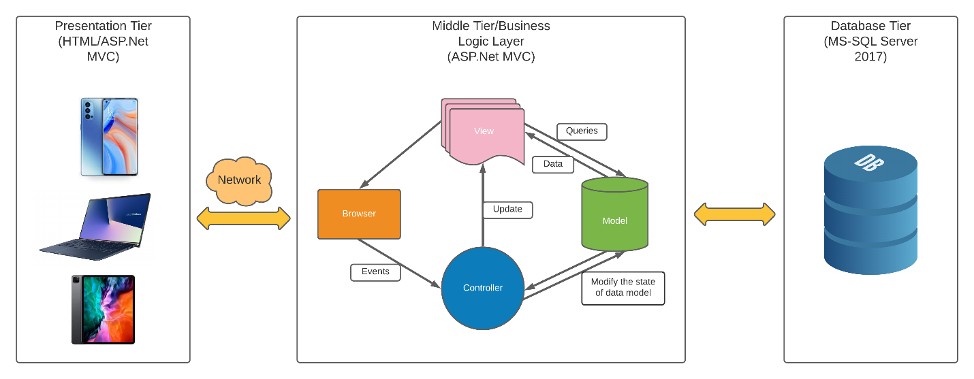

**\*Data Flow Diagram**

1. **Context diagram:**

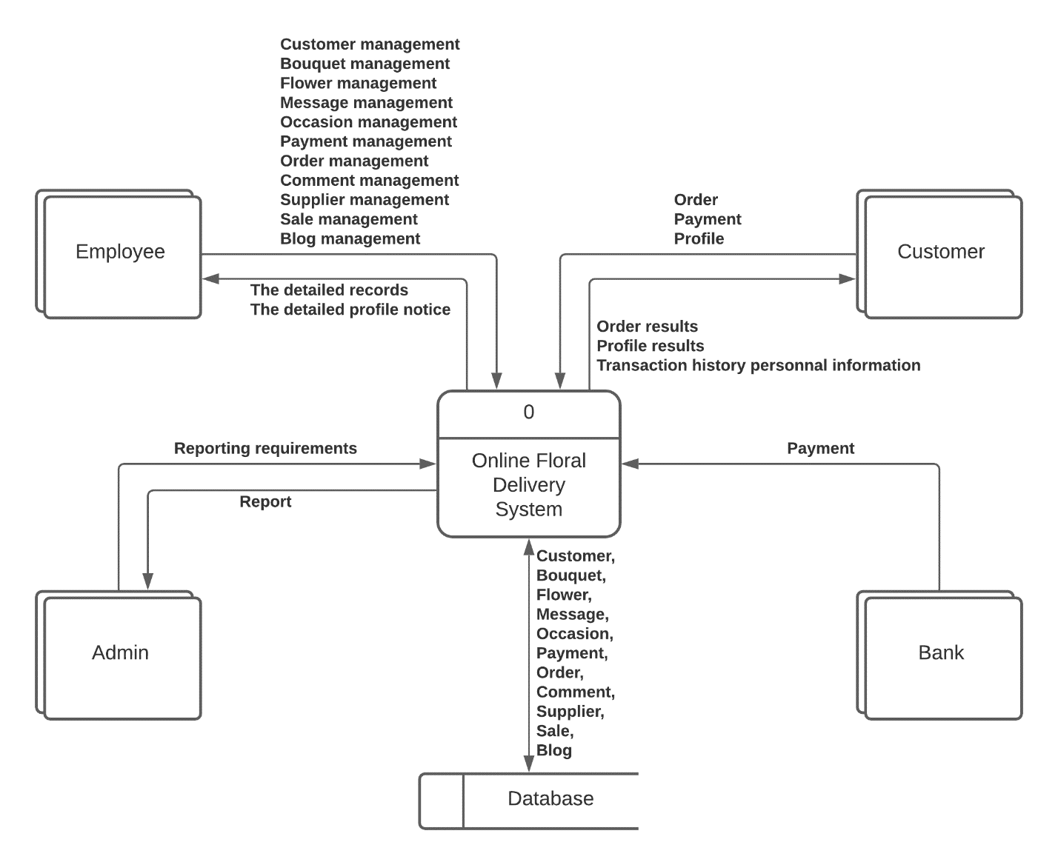

1. **Level 1 diagram:**
   1. **Process** **name:** Manage Customer

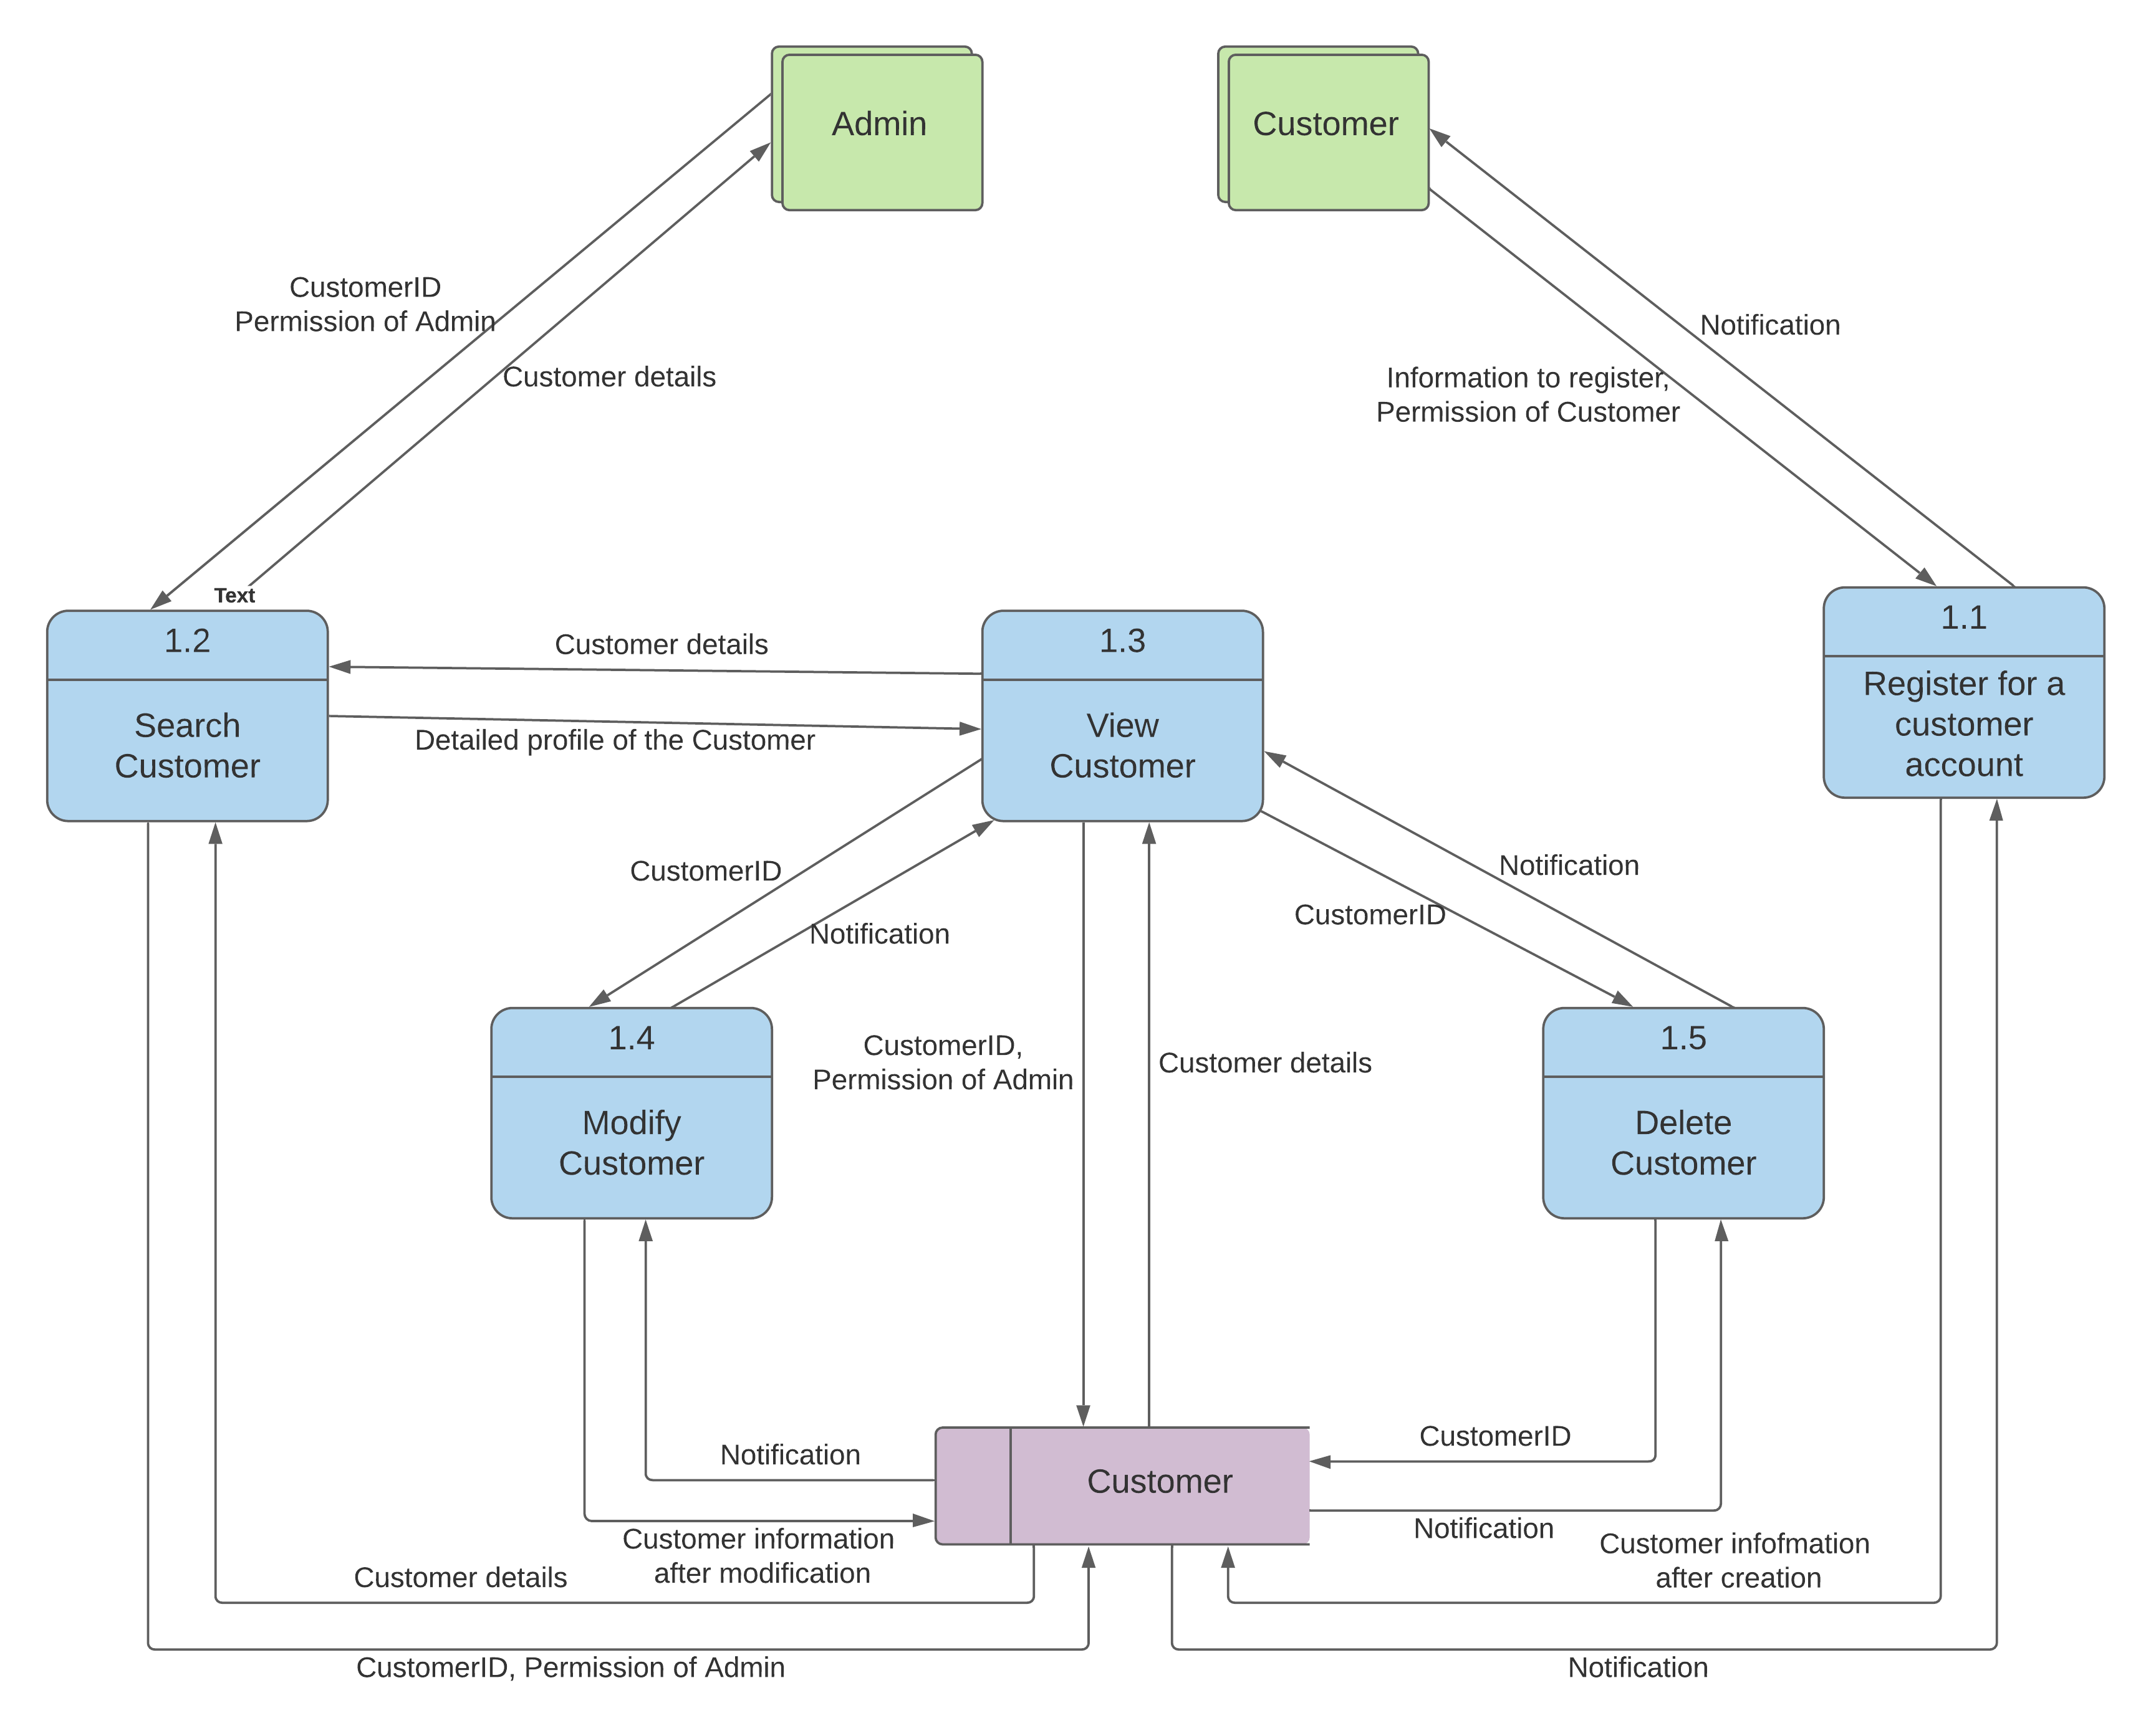

* 1. **Process** **name:** Manage Employee

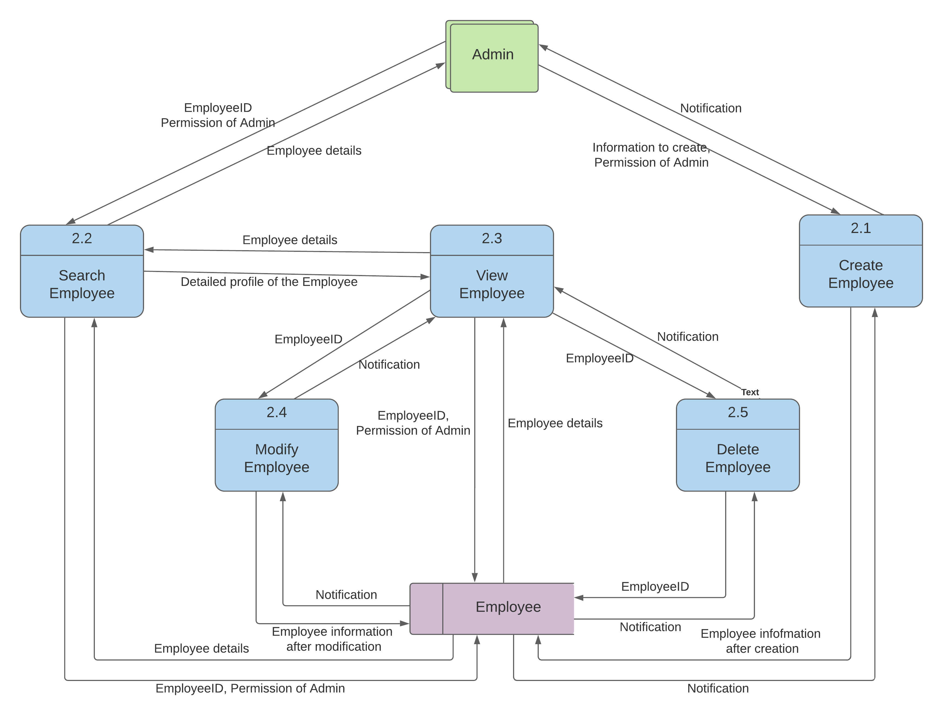

* 1. **Process** **name:** Manage Flower Type

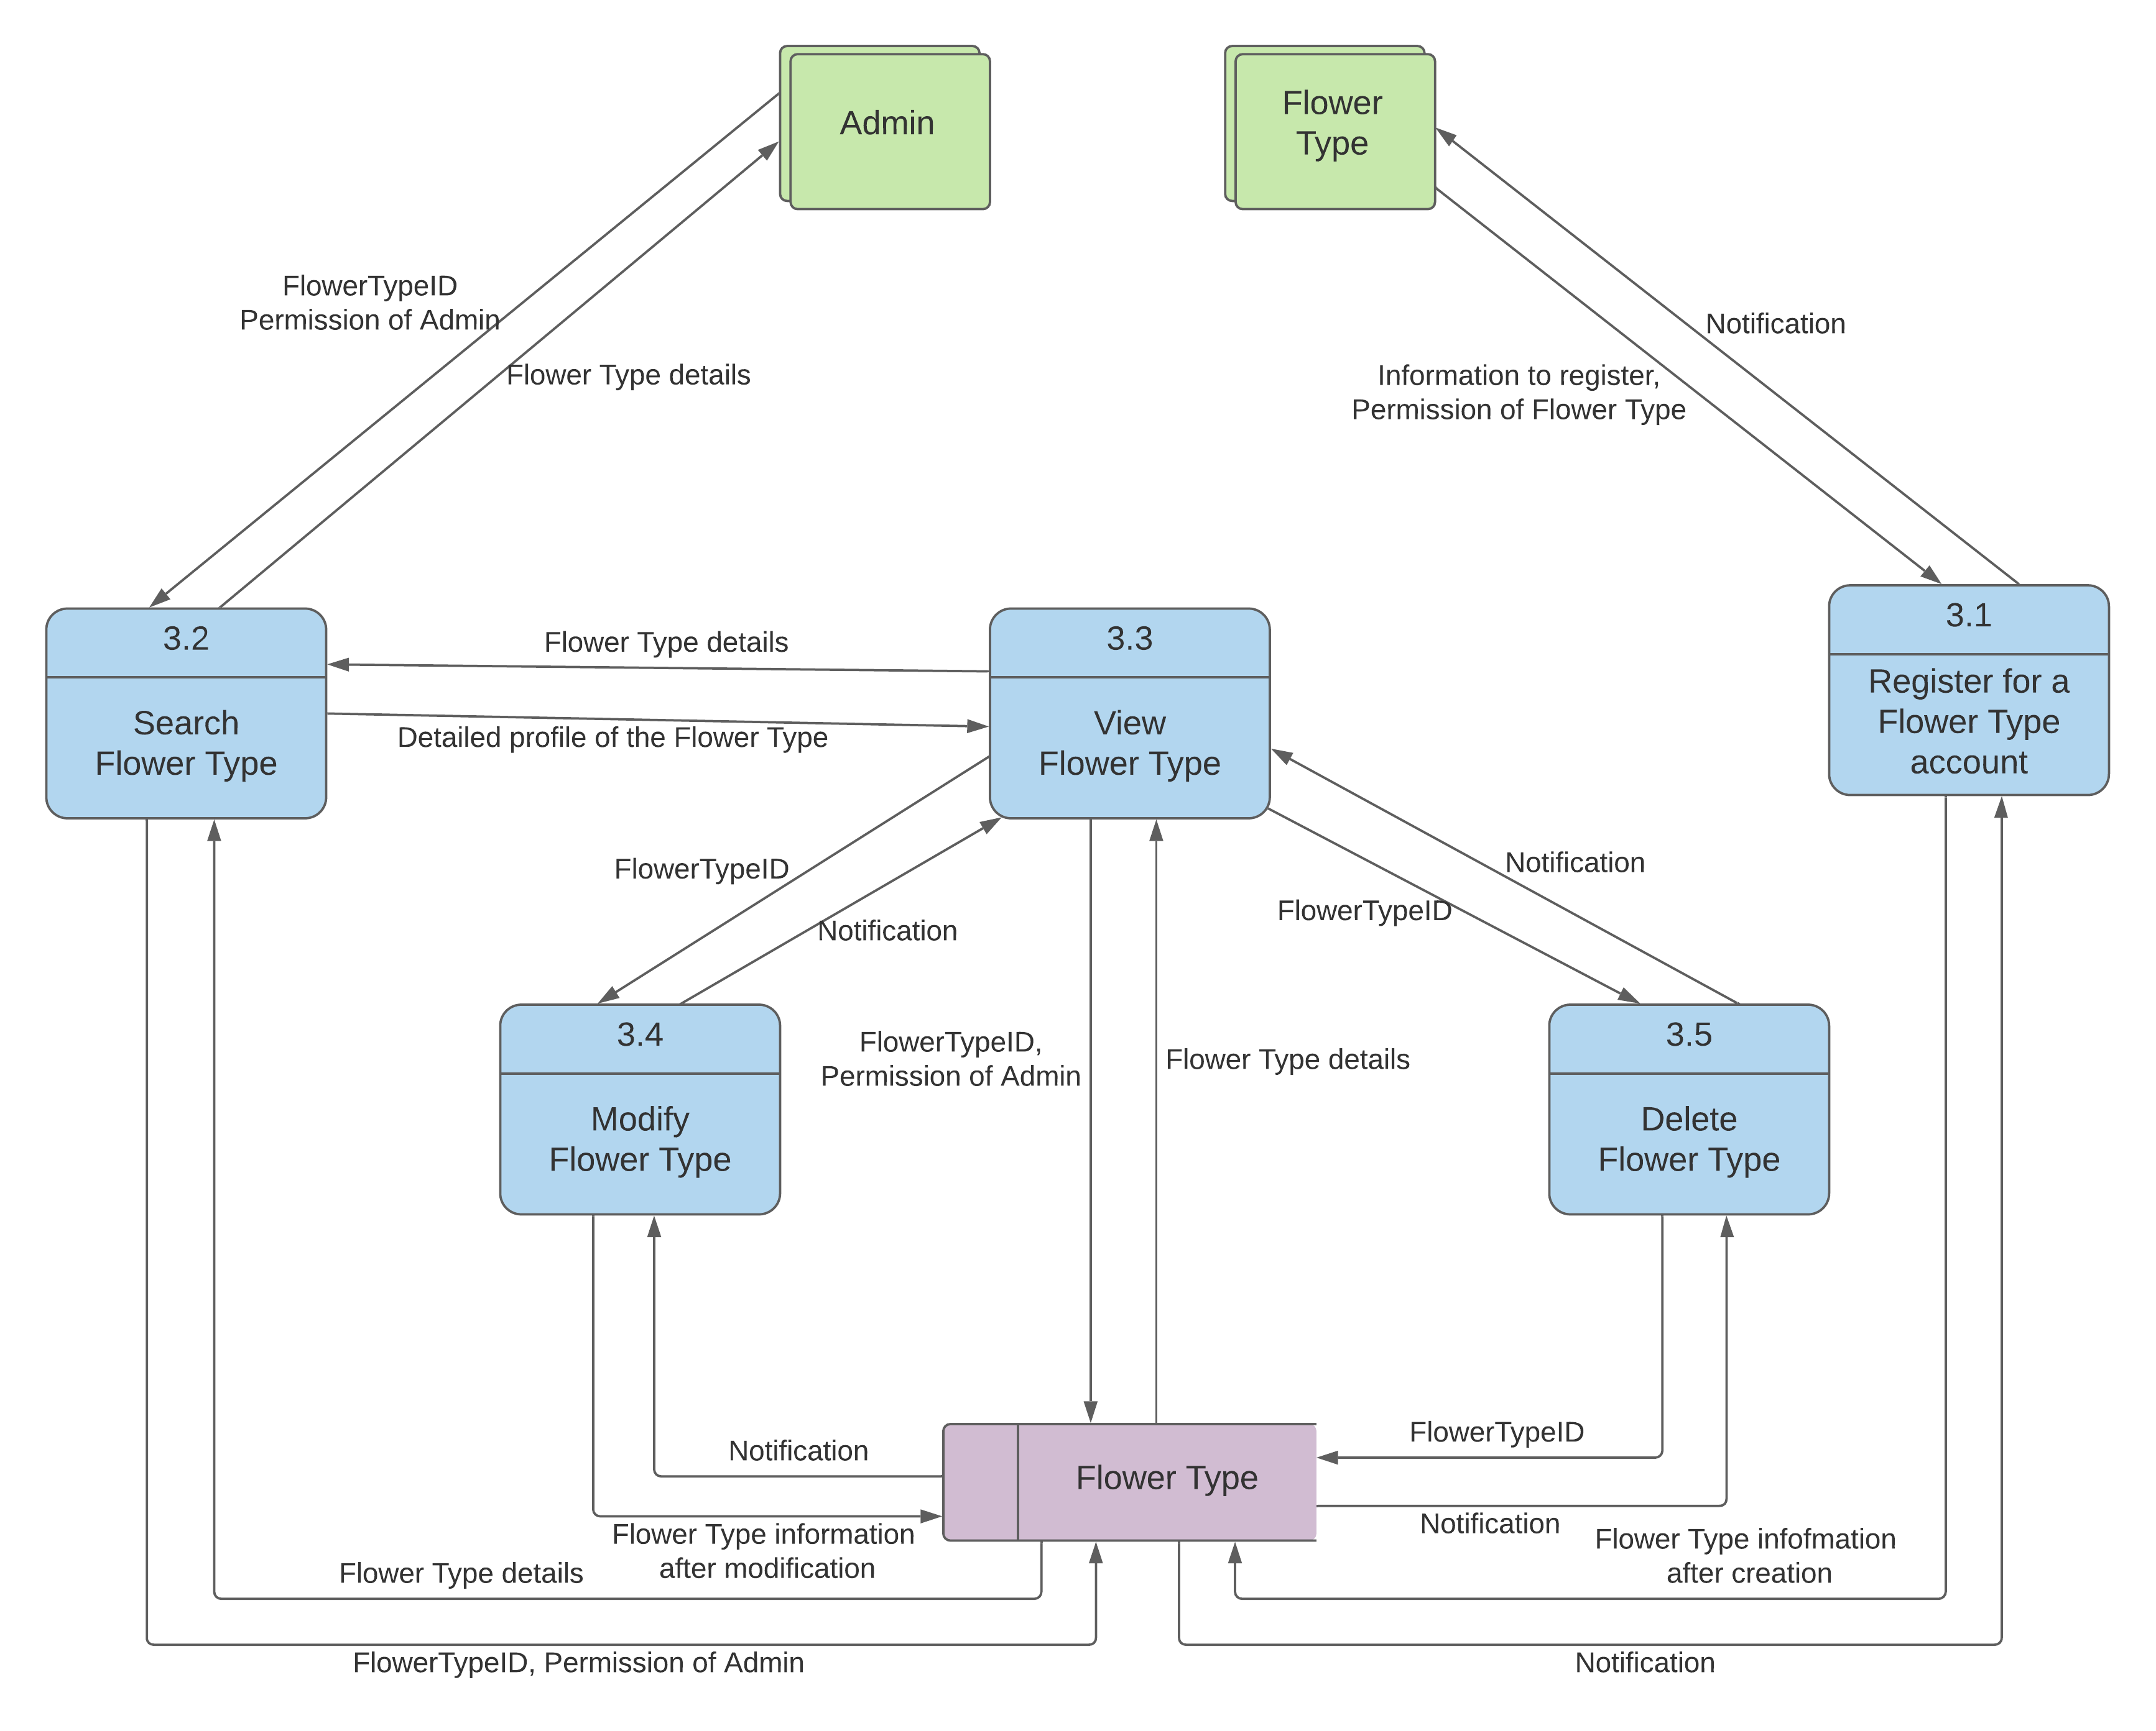

* 1. **Process** **name:** Manage Bouquet

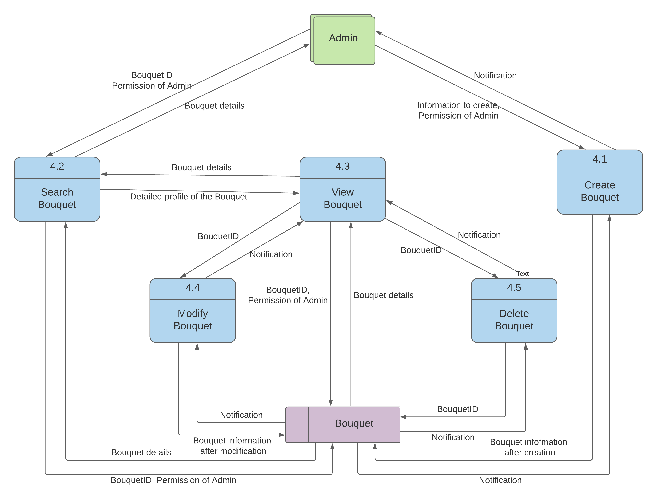

* 1. **Process** **name:** Manage Bouquet Image

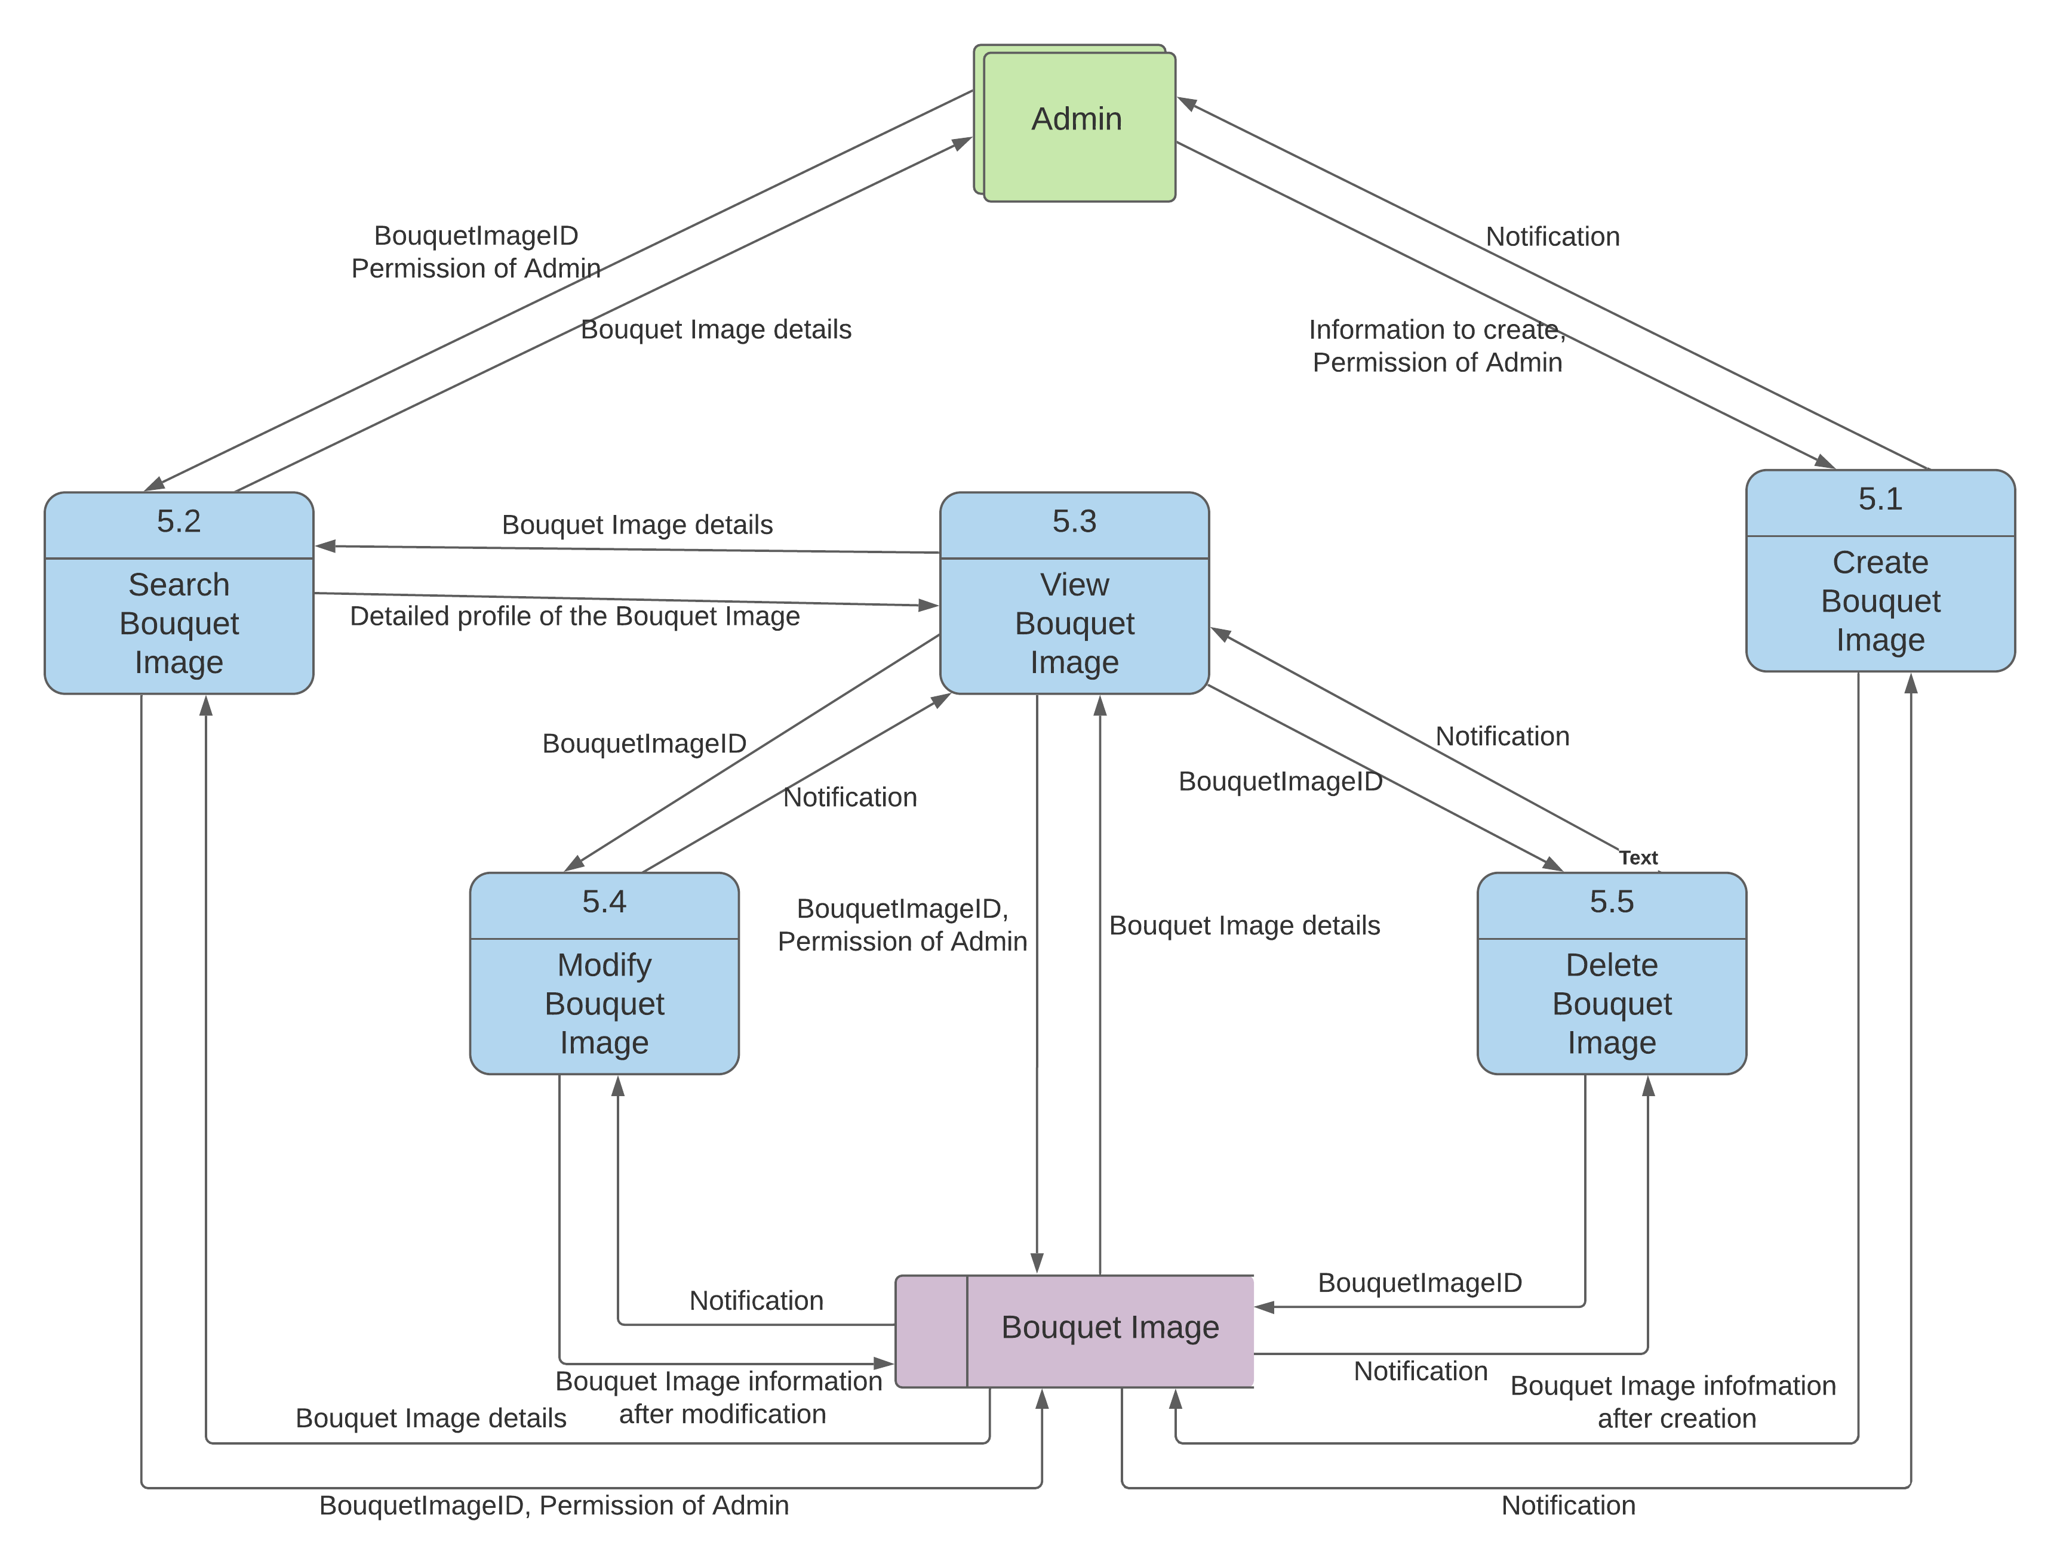

* 1. **Process** **name:** Manage Occasion

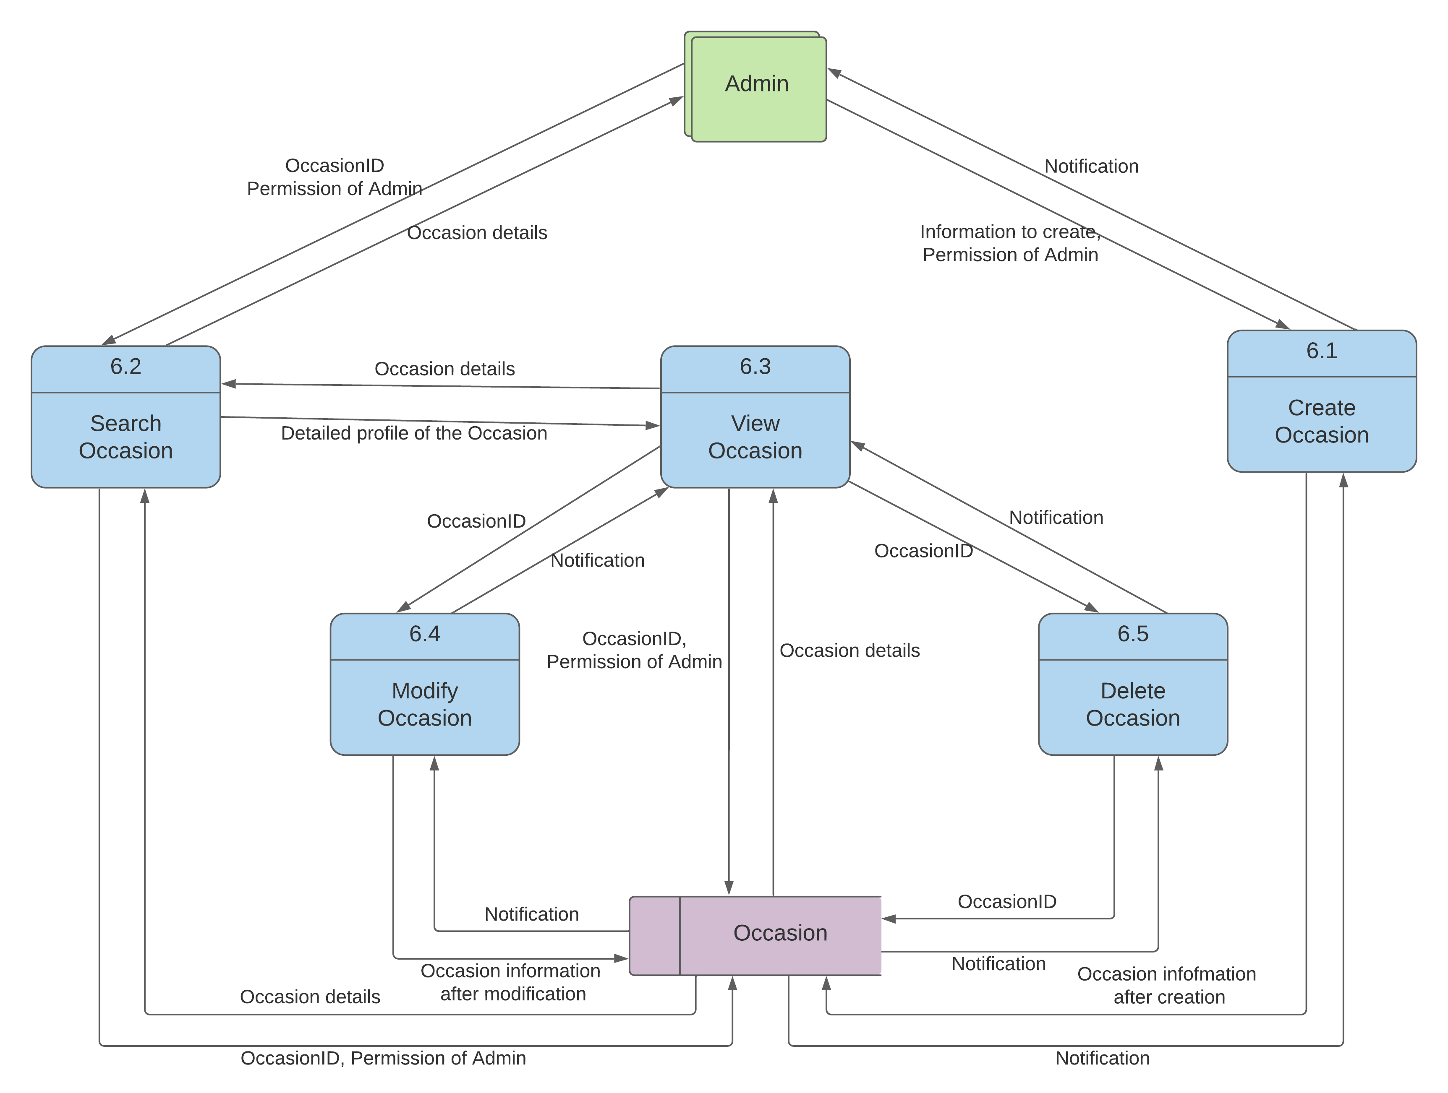

* 1. **Process** **name:** Manage Message

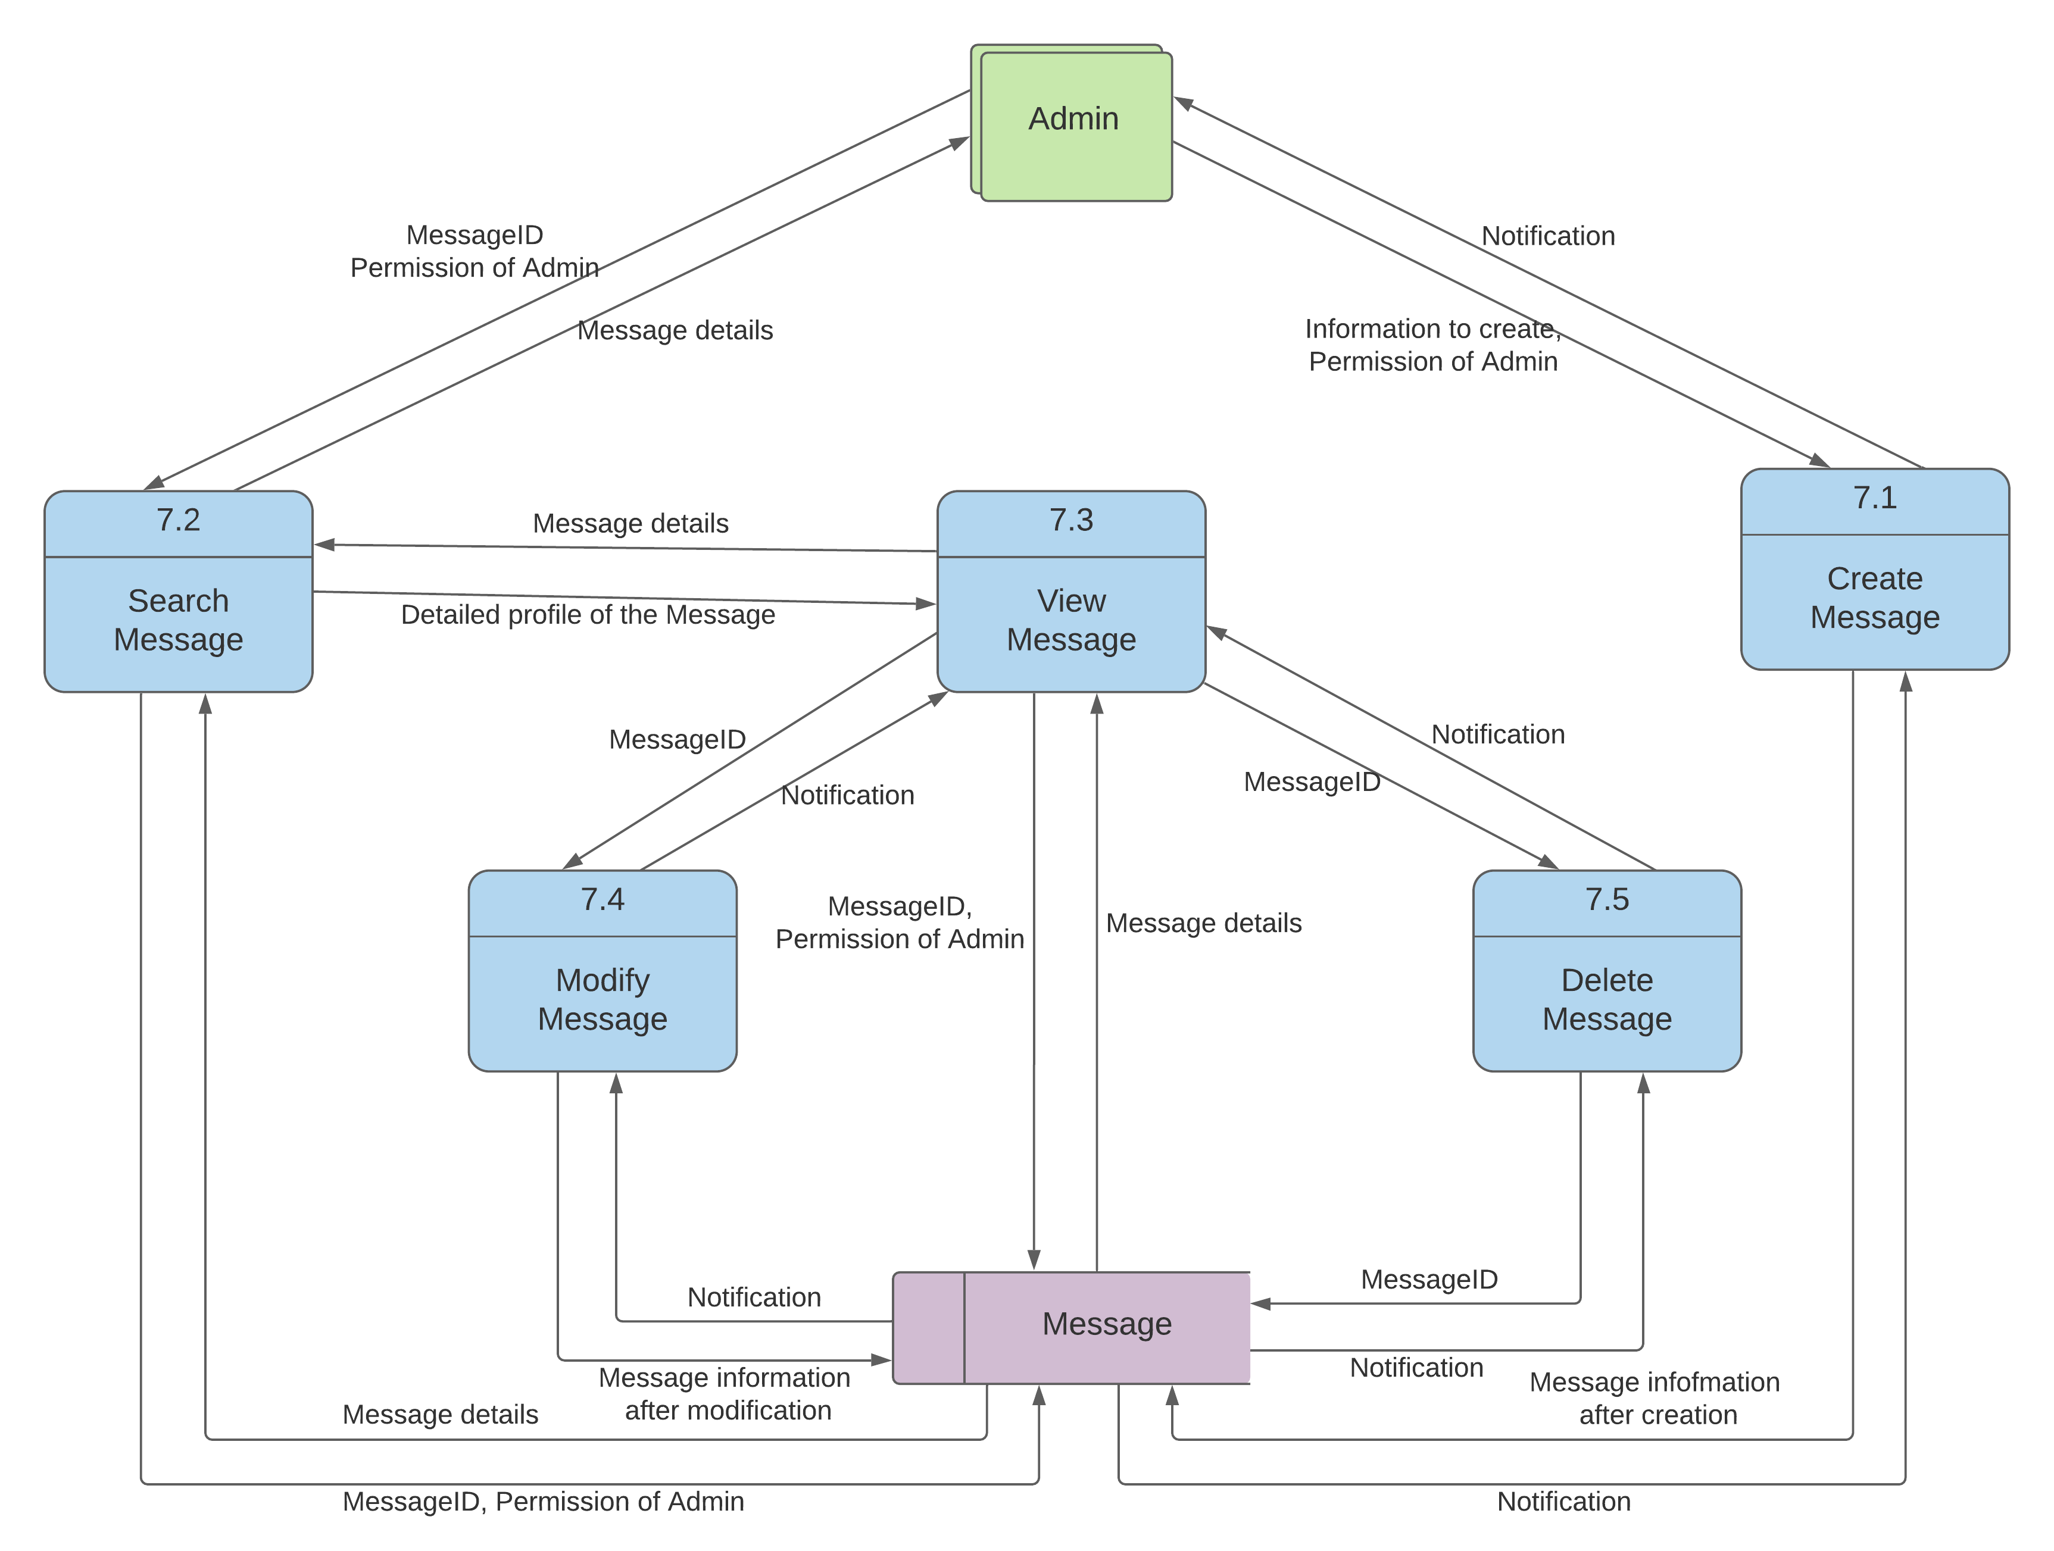

* 1. **Process** **name:** Manage Payment

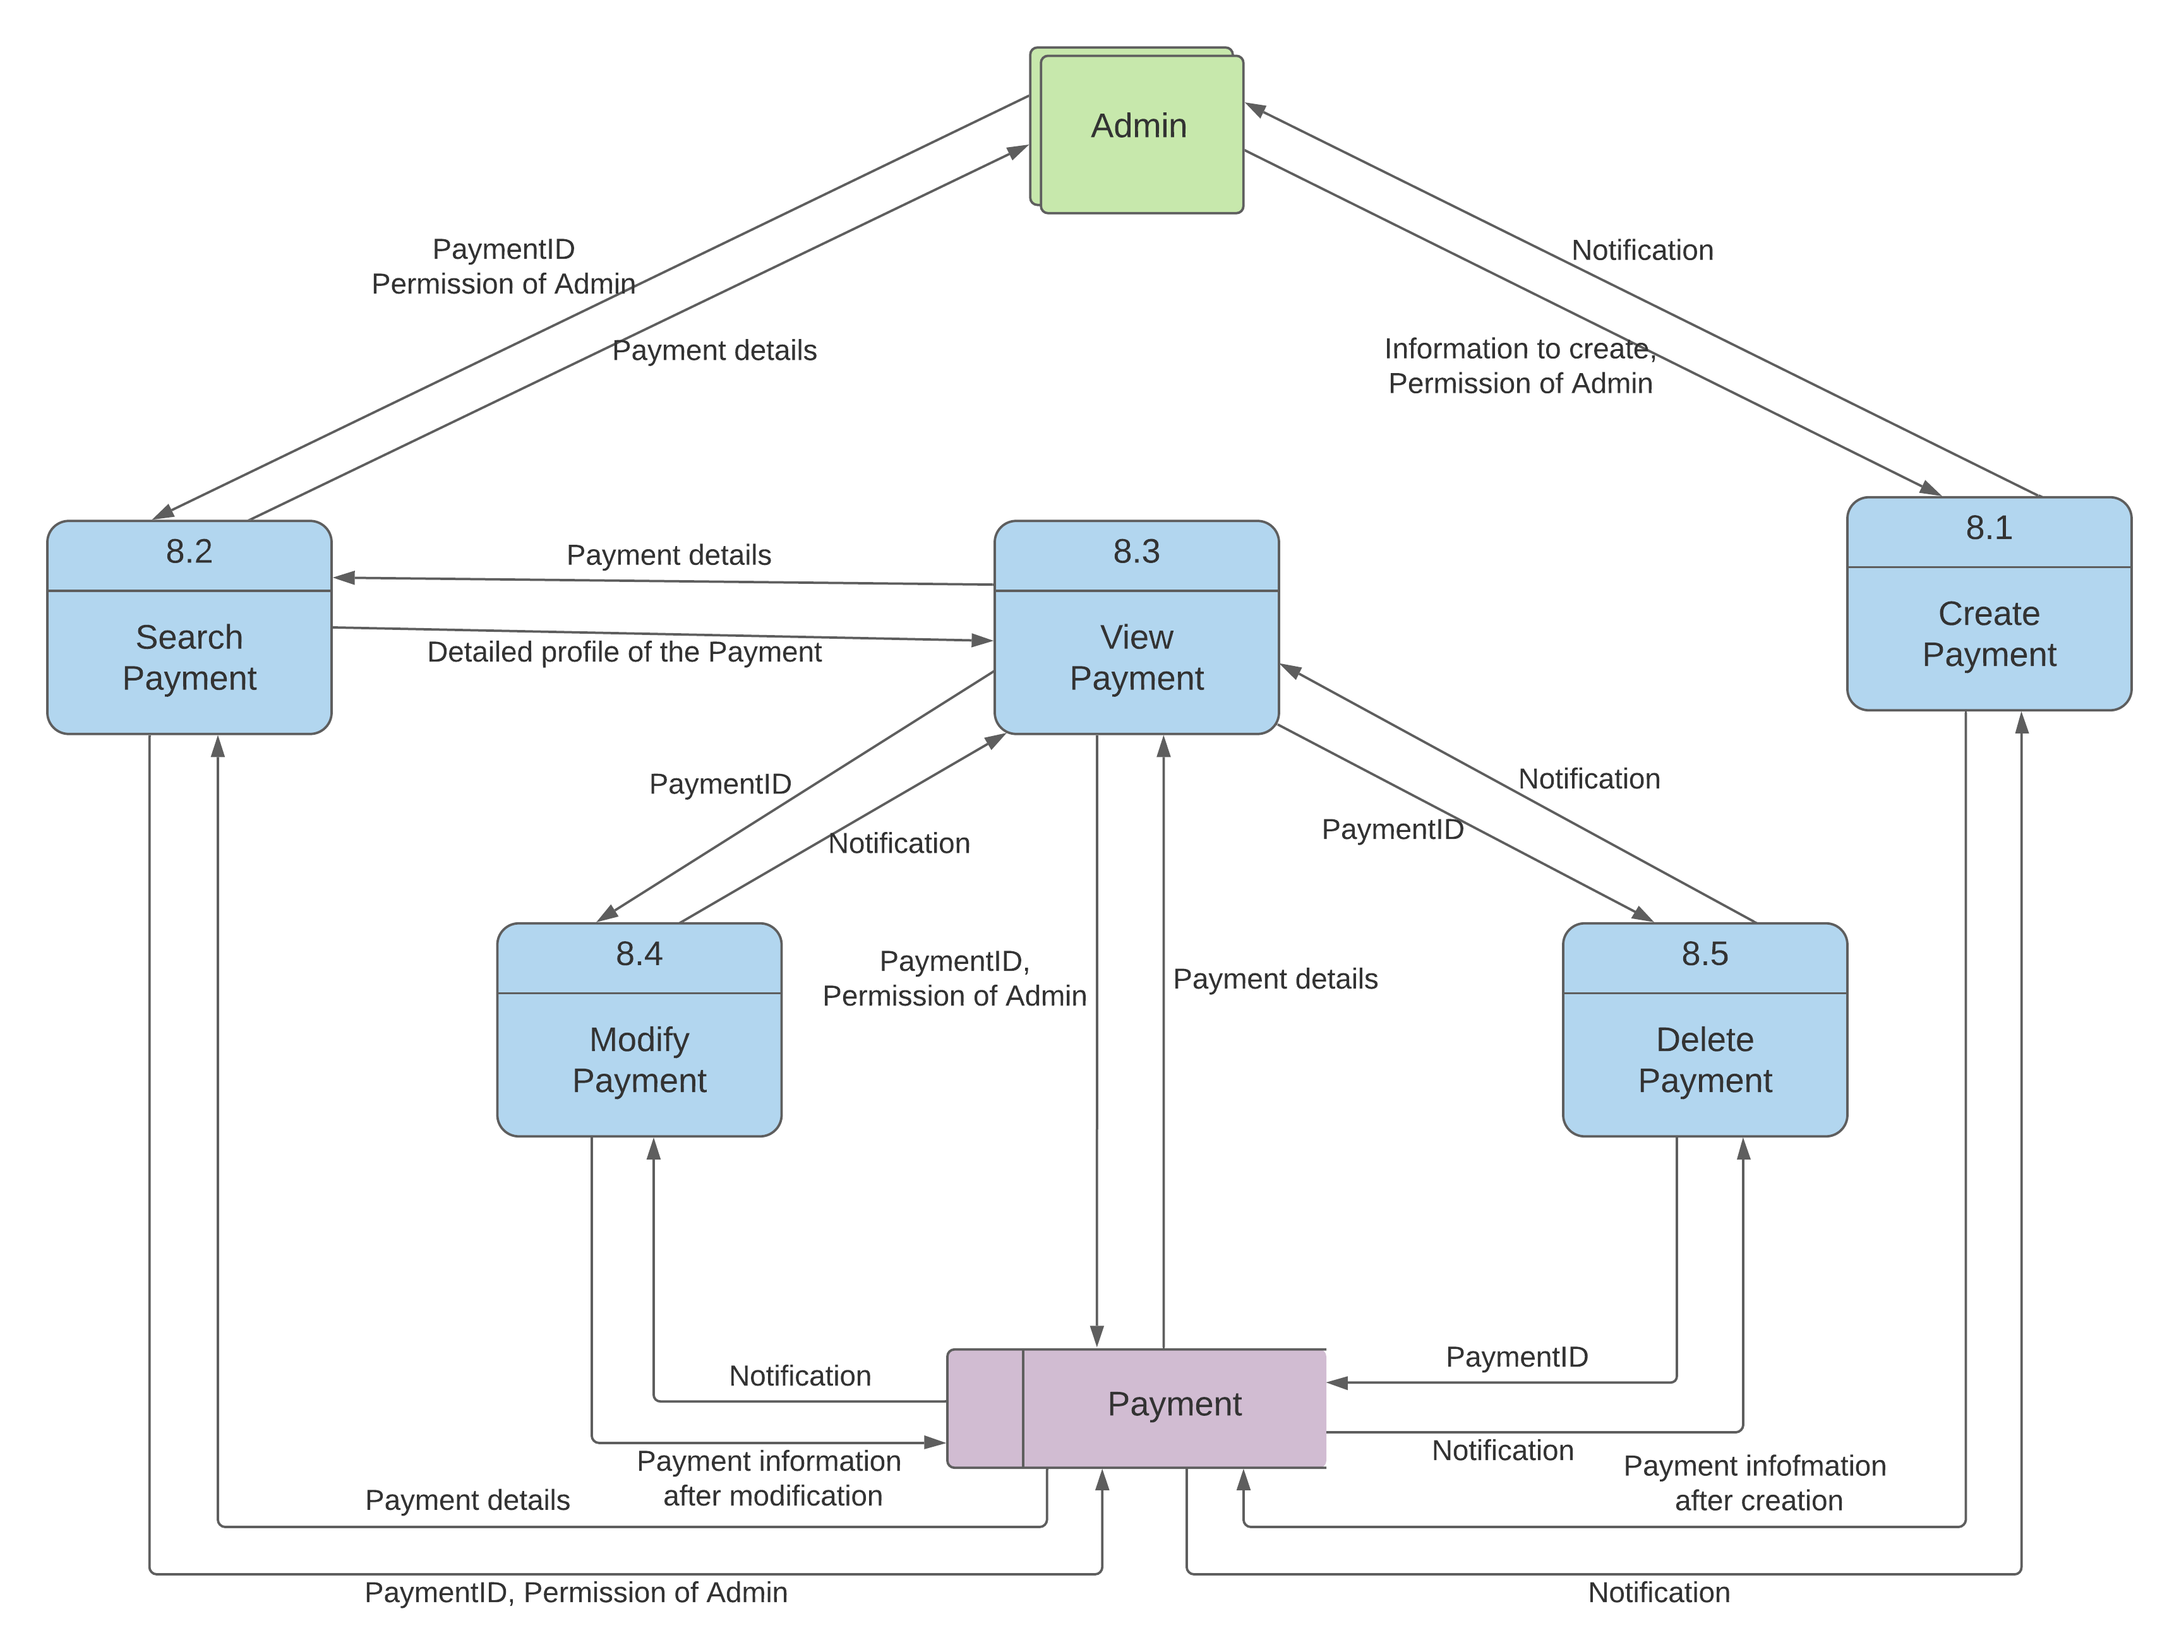

* 1. **Process** **name:** Manage Order

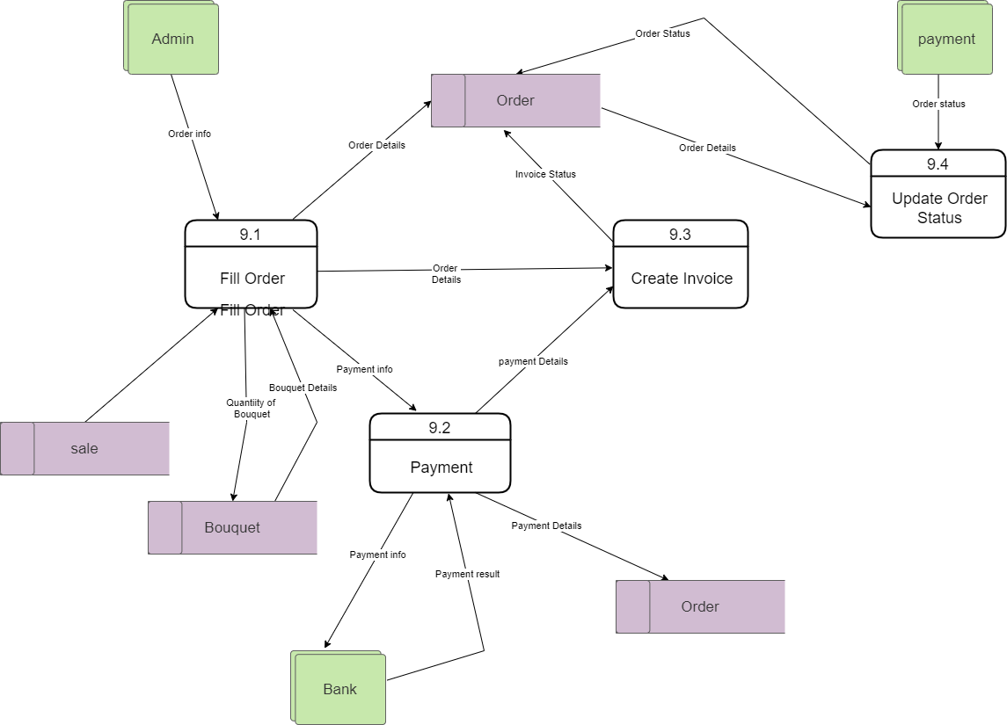

* 1. **Process** **name:** Manage Suppliers

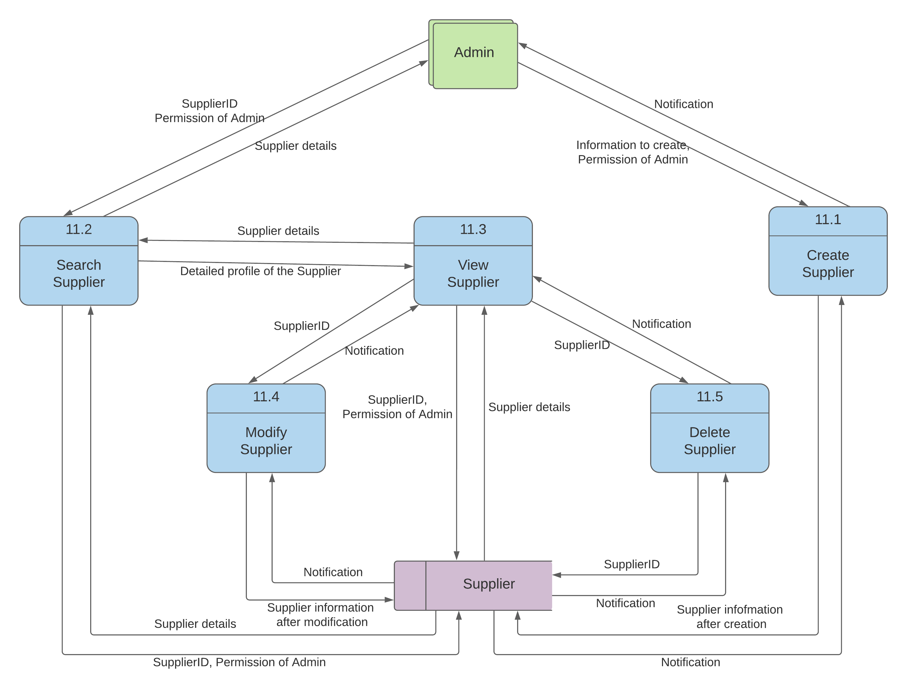

* 1. **Process** **name:** Manage Sales

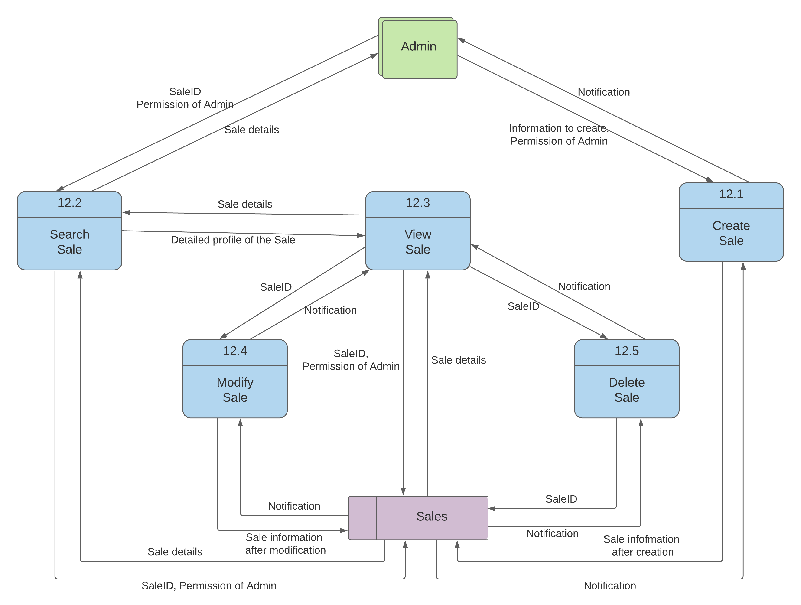

* 1. **Process** **name:** Manage Blog Categories

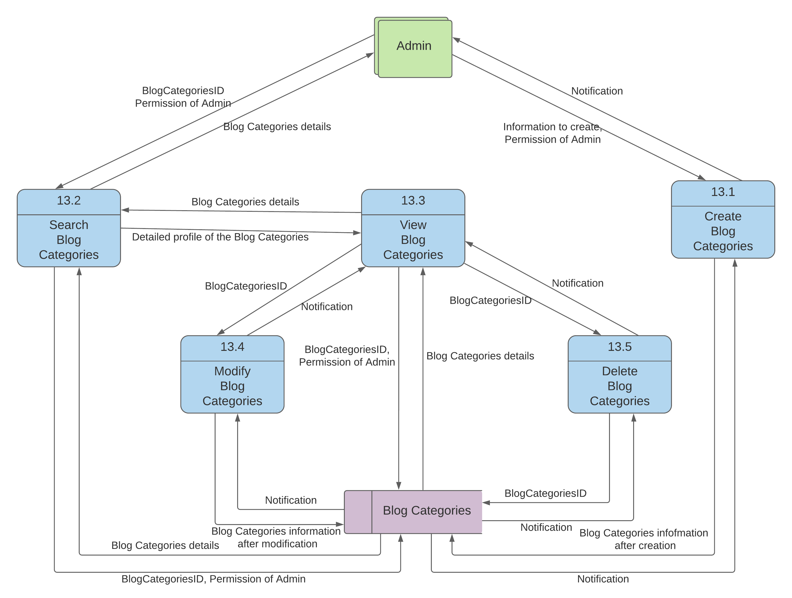

* 1. **Process** **name:** Manage Blog

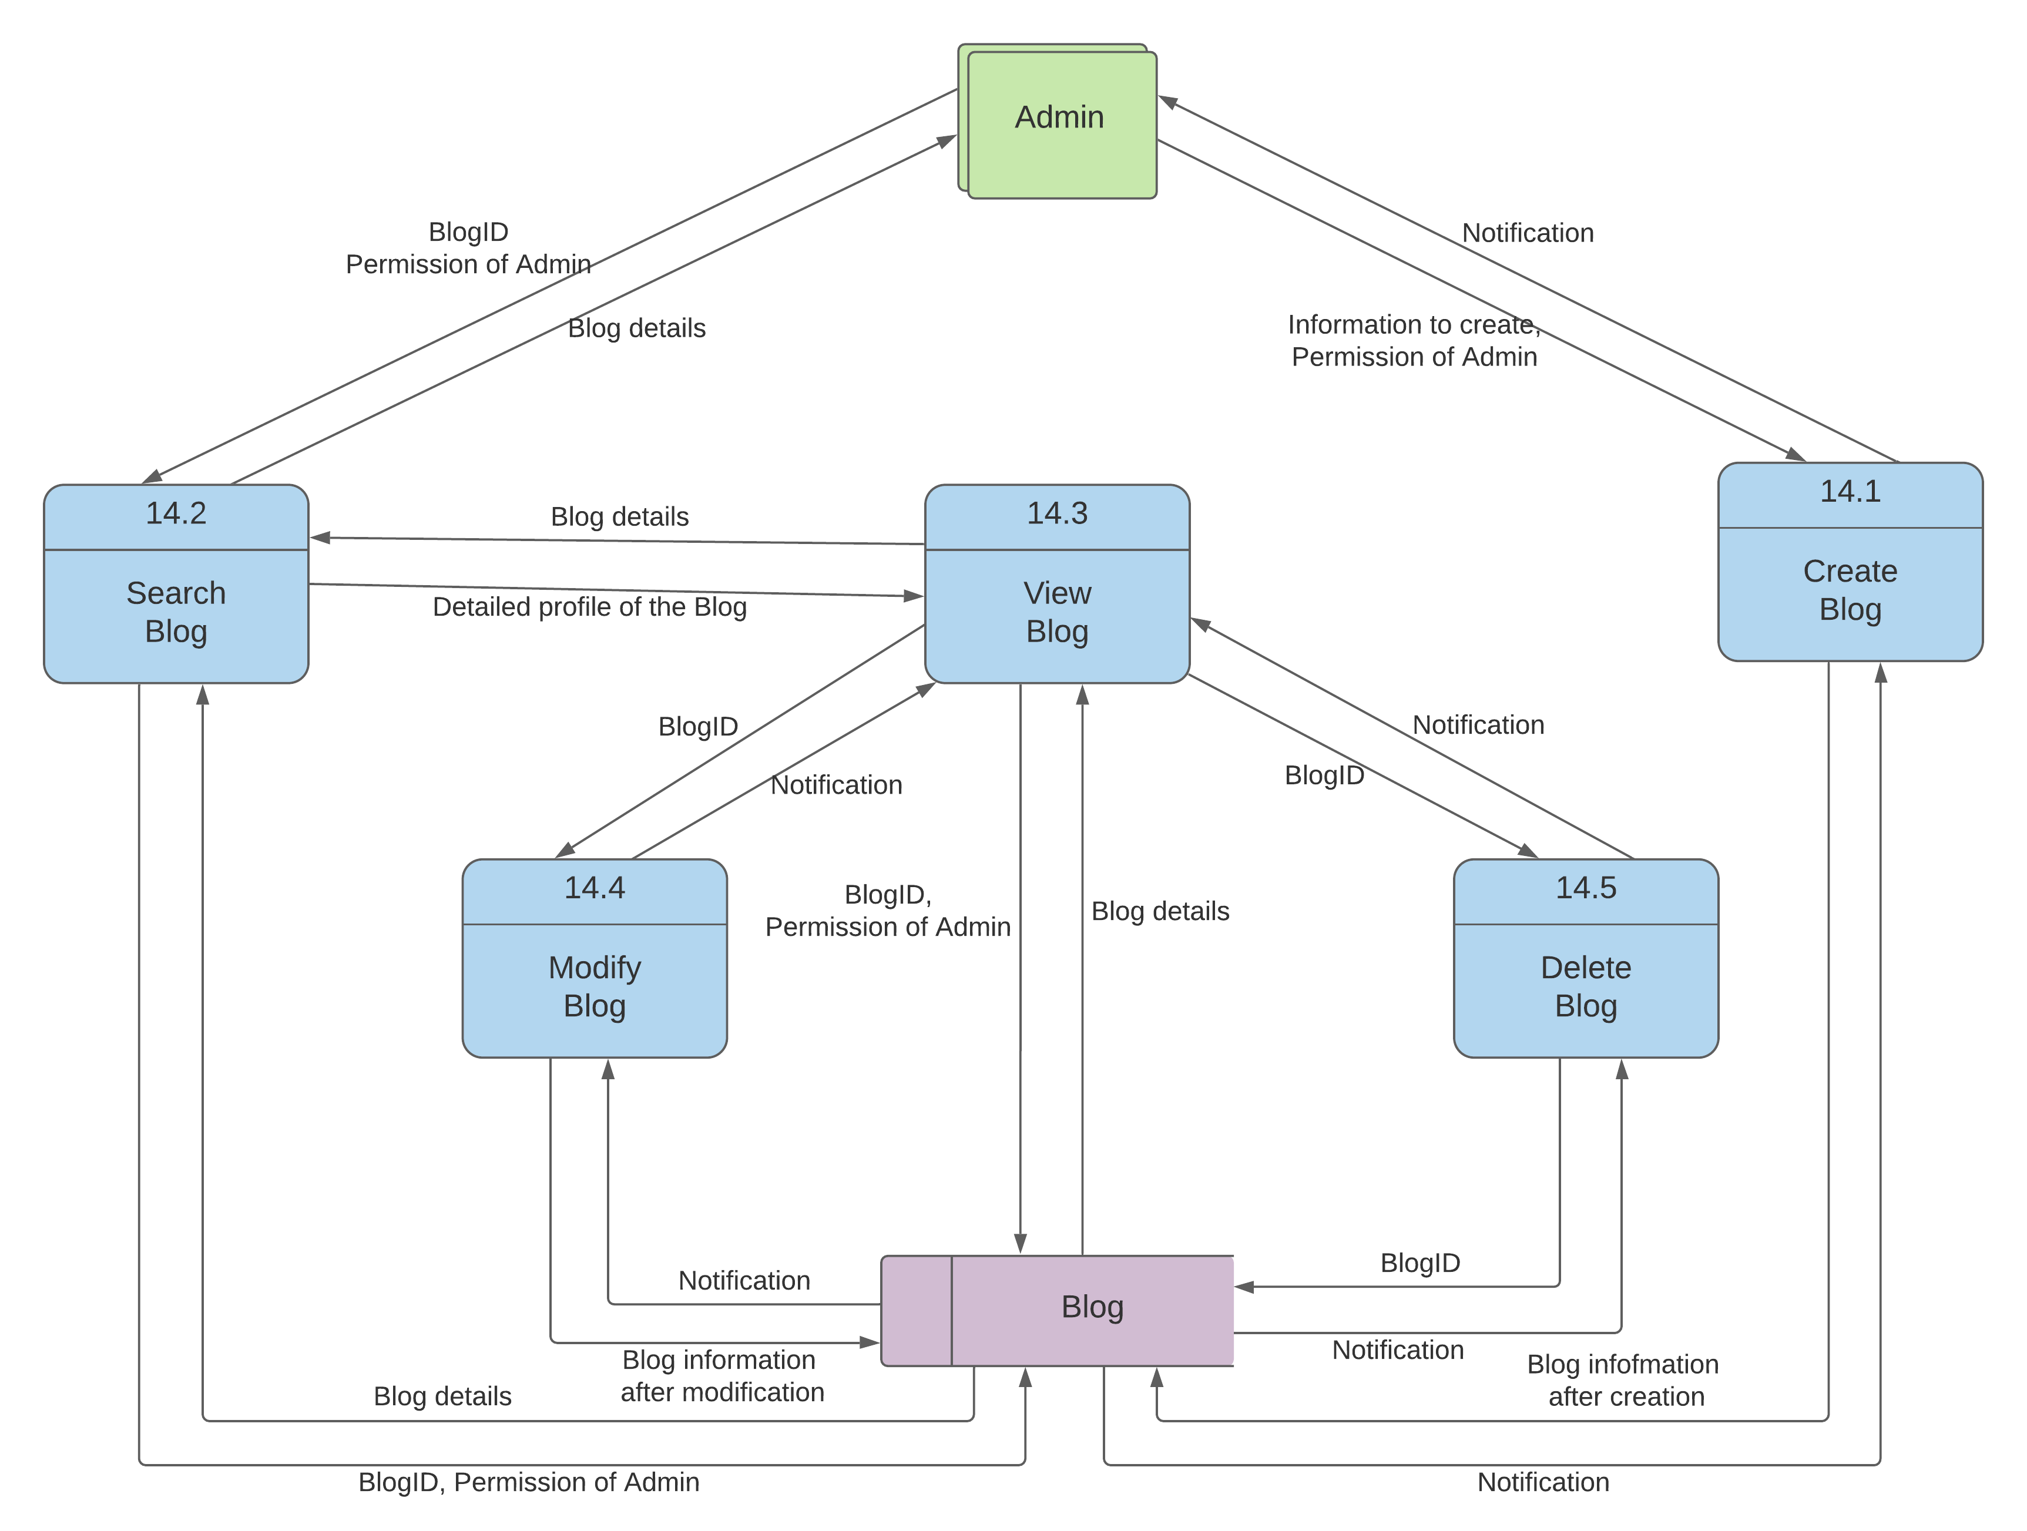

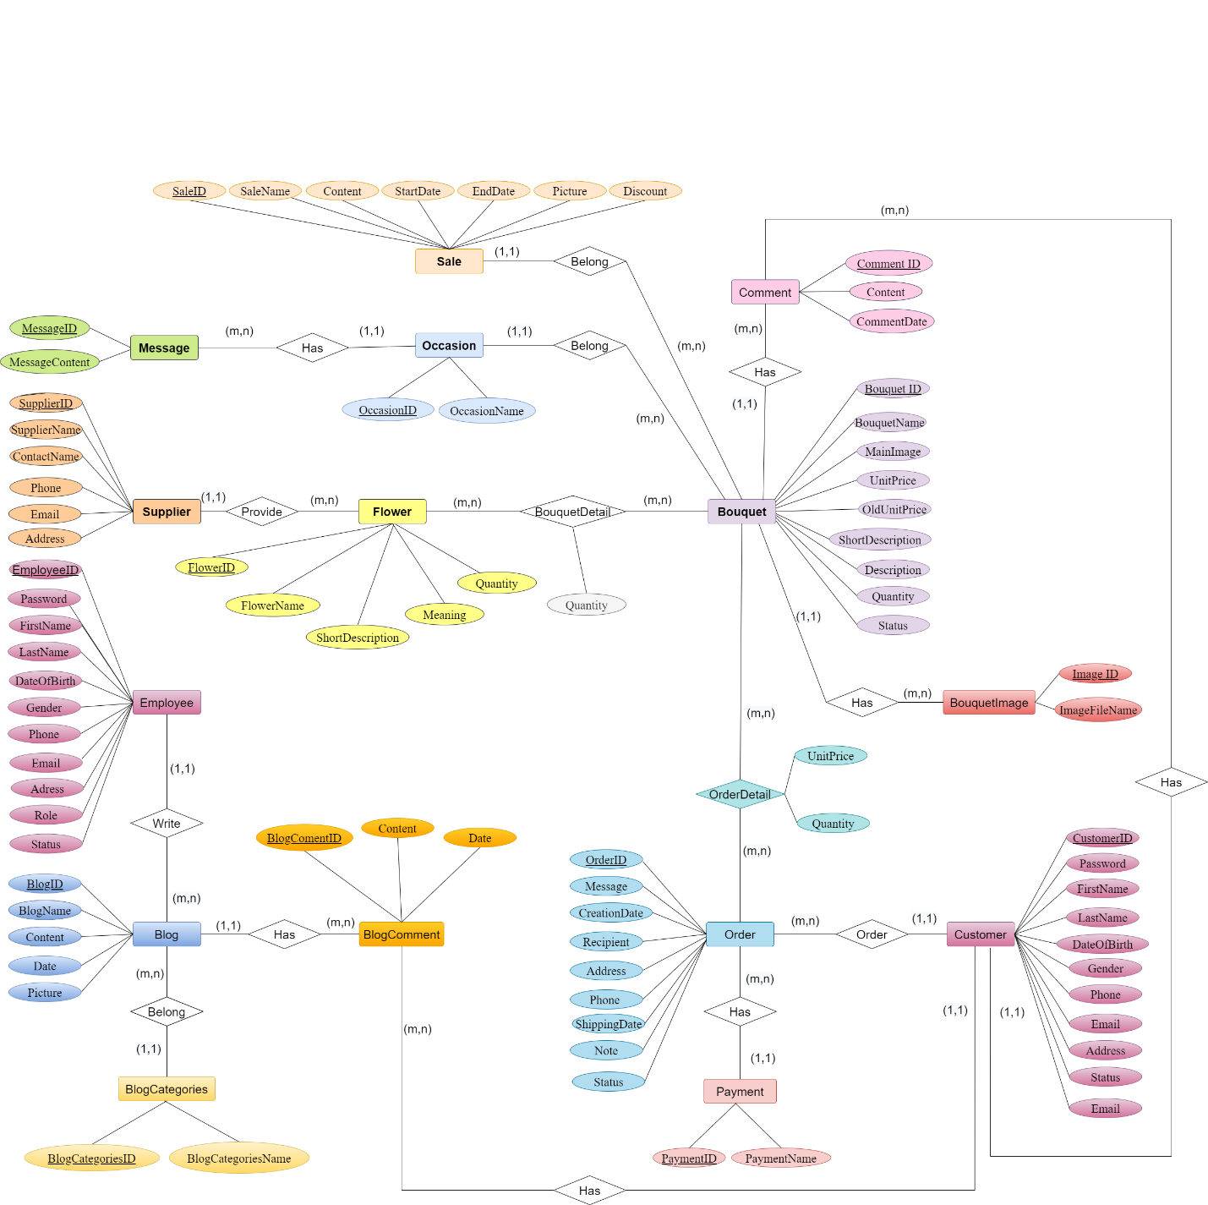**\*ER:**

**\*Flowchart:**

1. Employee , Admin:
   1. Manage Customer:

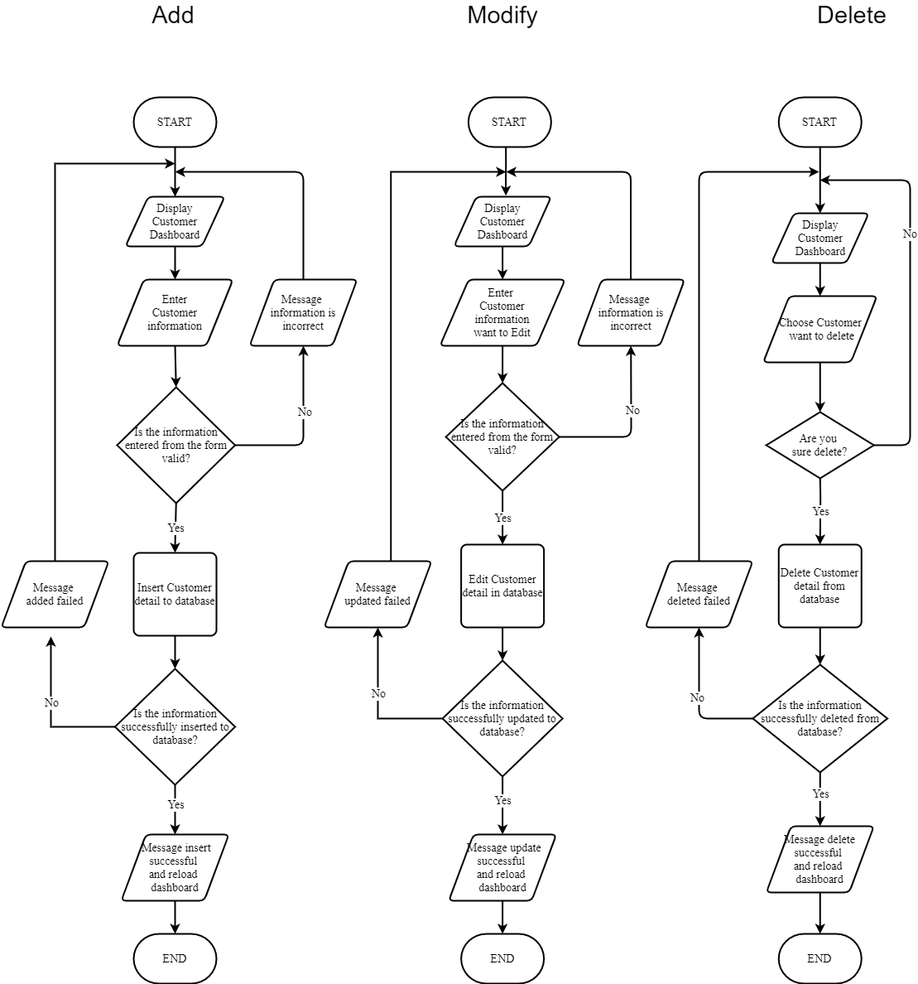

* 1. Manage Employee:

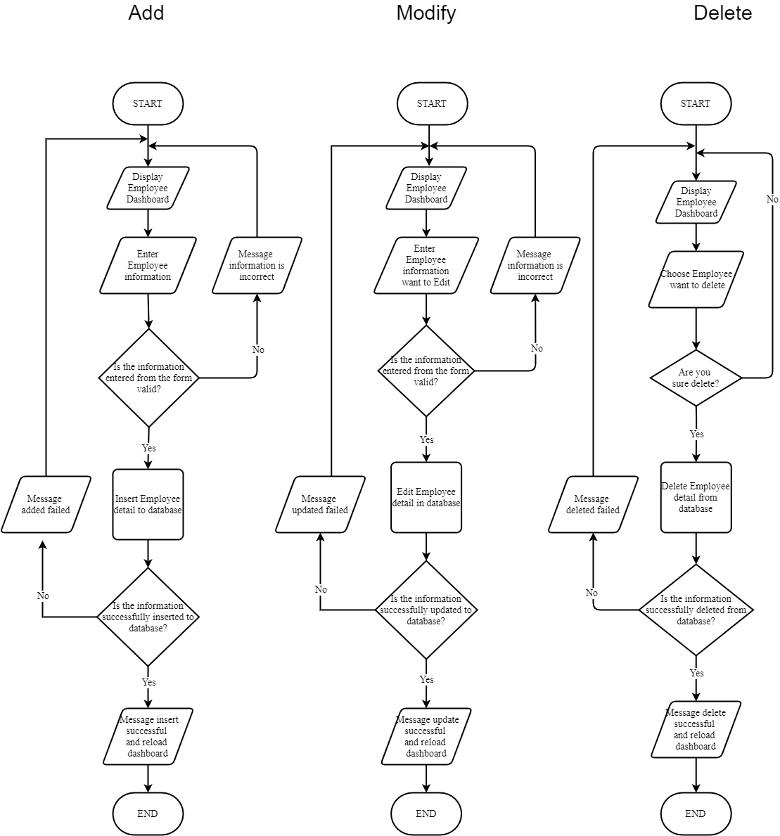

* 1. Manage Flower Type

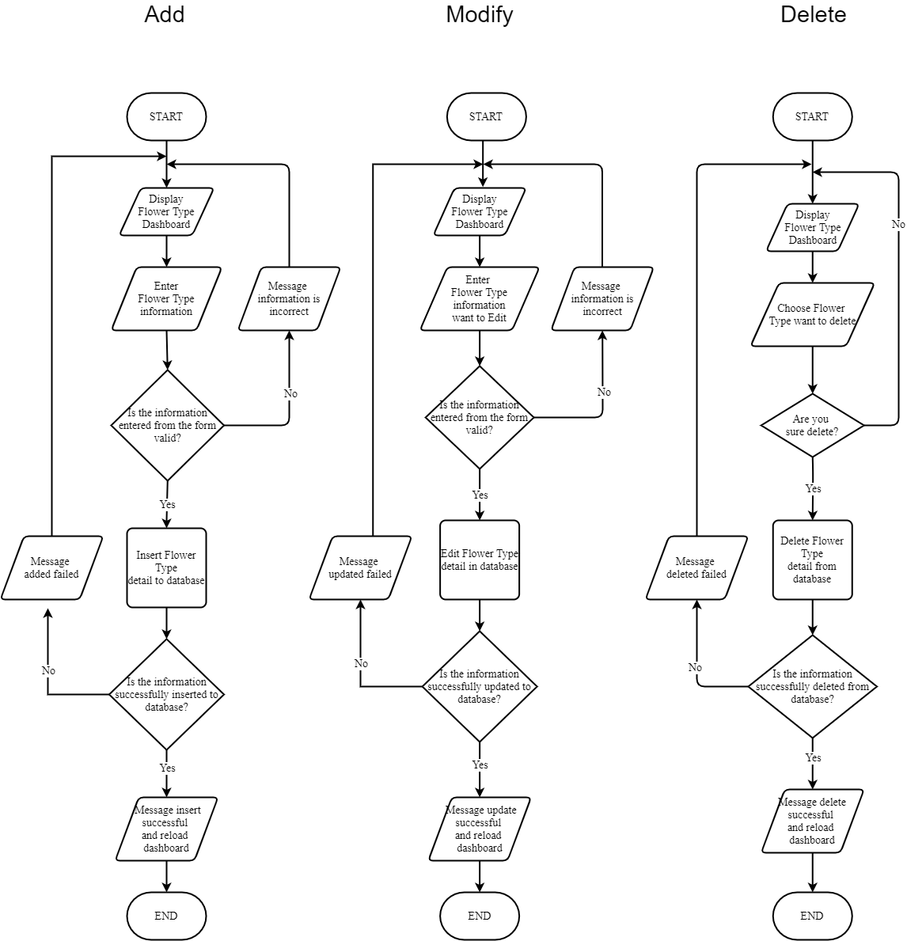

* 1. Manage bouquet:

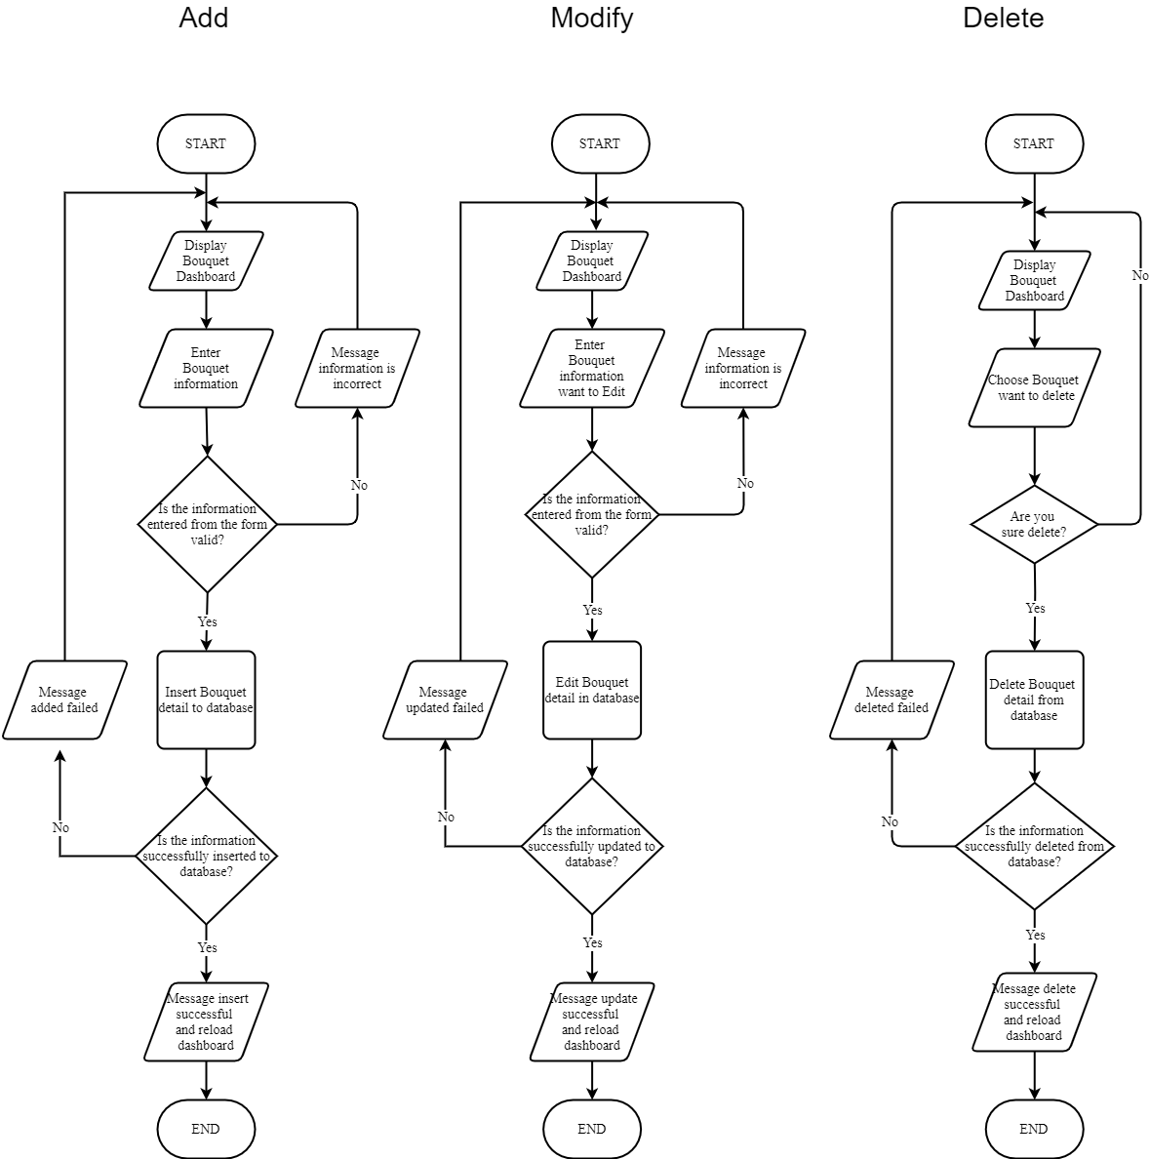

* 1. Manage Bouquet Image:

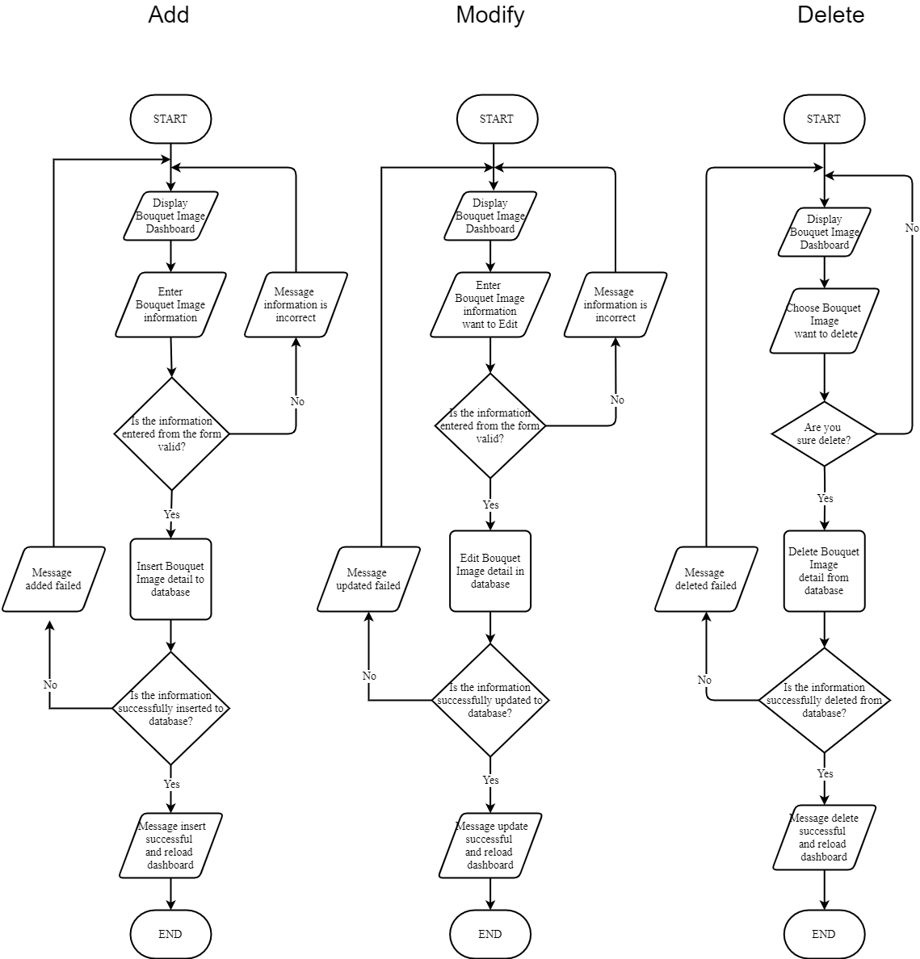

* 1. Manage Occasion

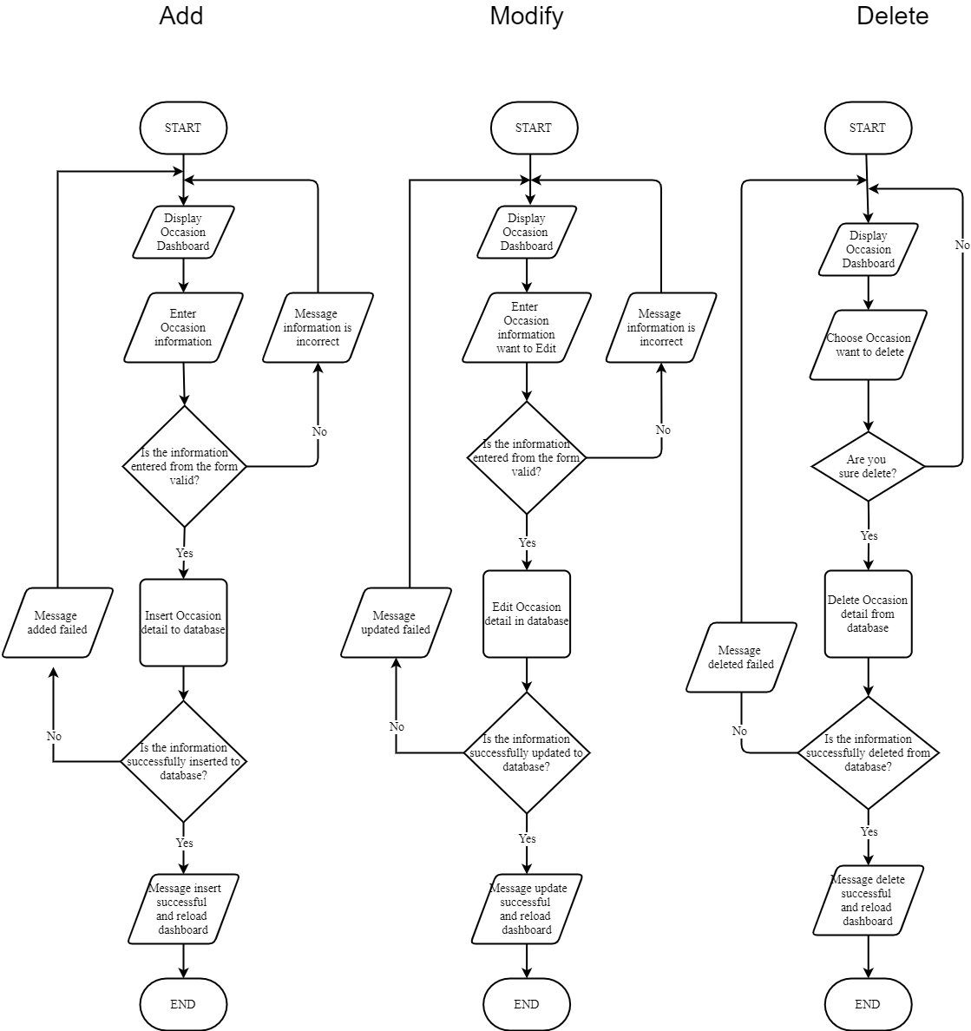

* 1. Manage Message

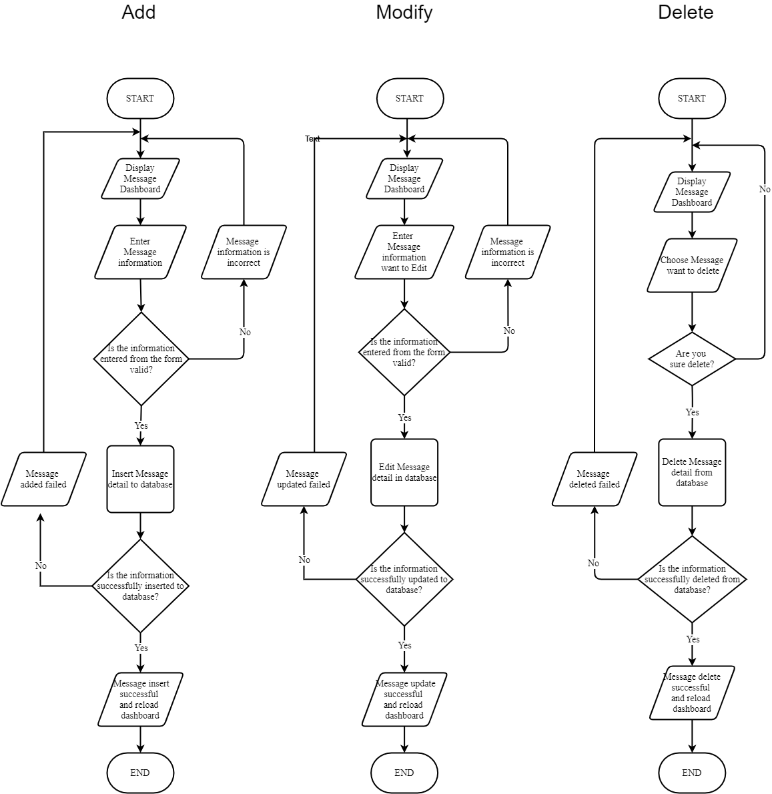

* 1. Manage Payment

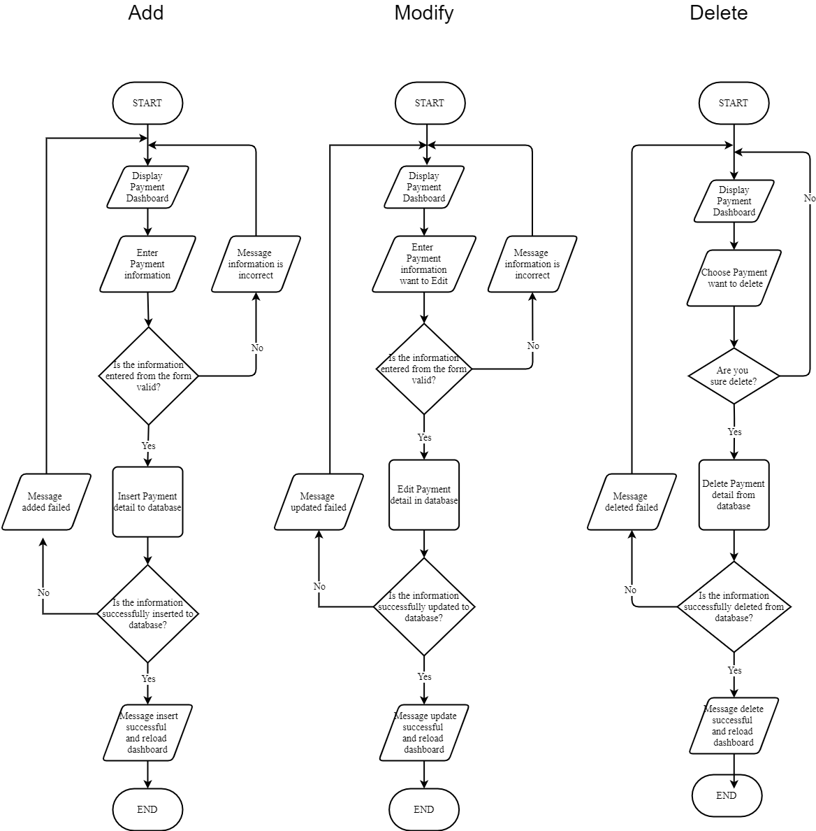

* 1. Manage Suplier

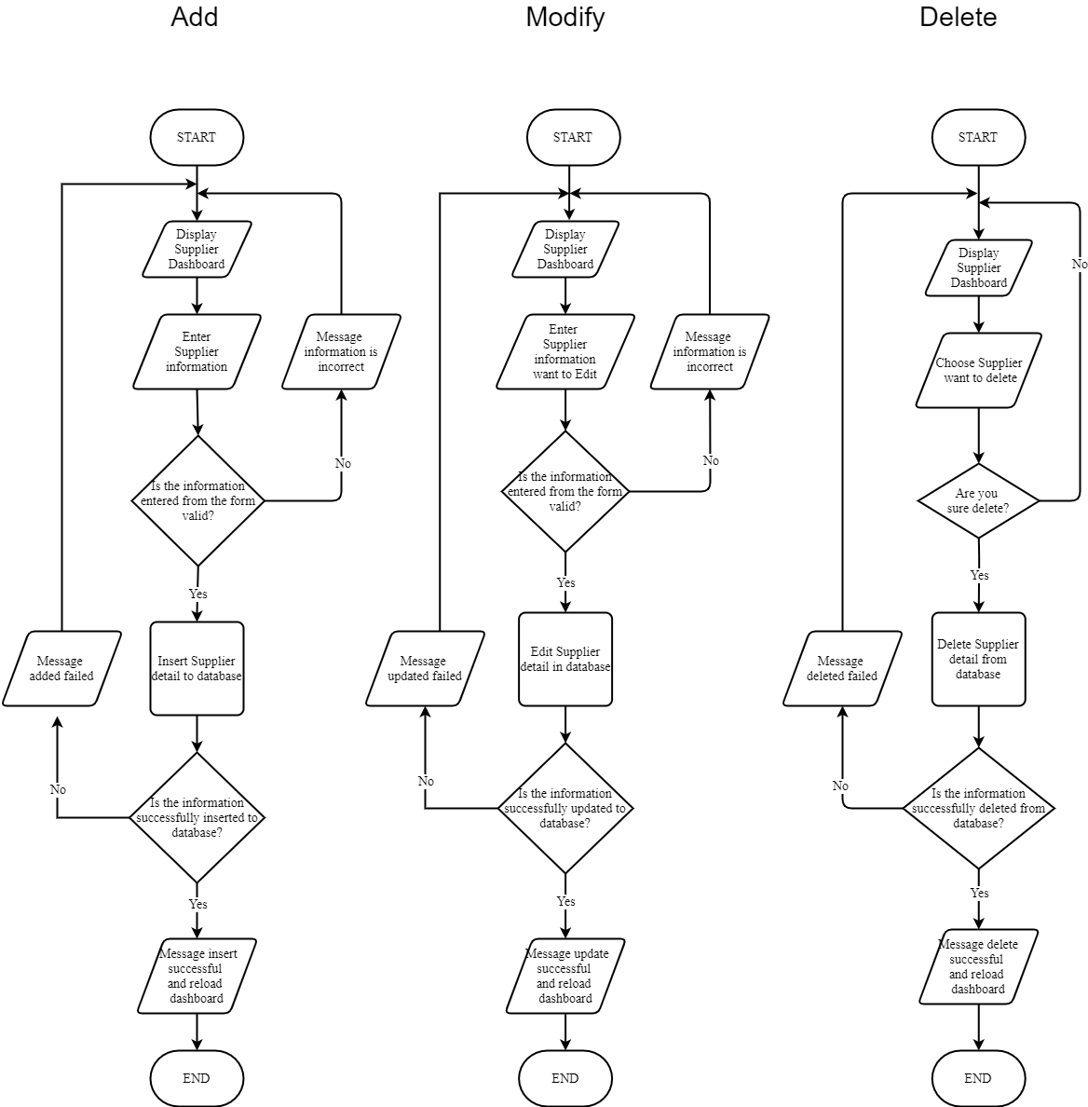

* 1. Manage Blog Categories

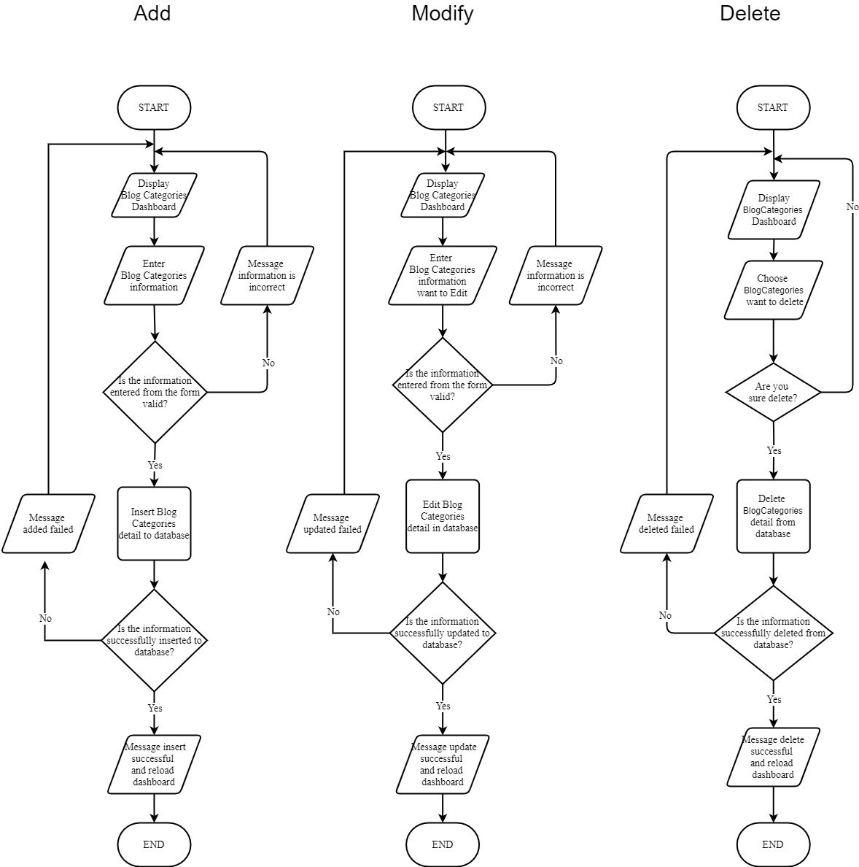

* 1. Manage Blog

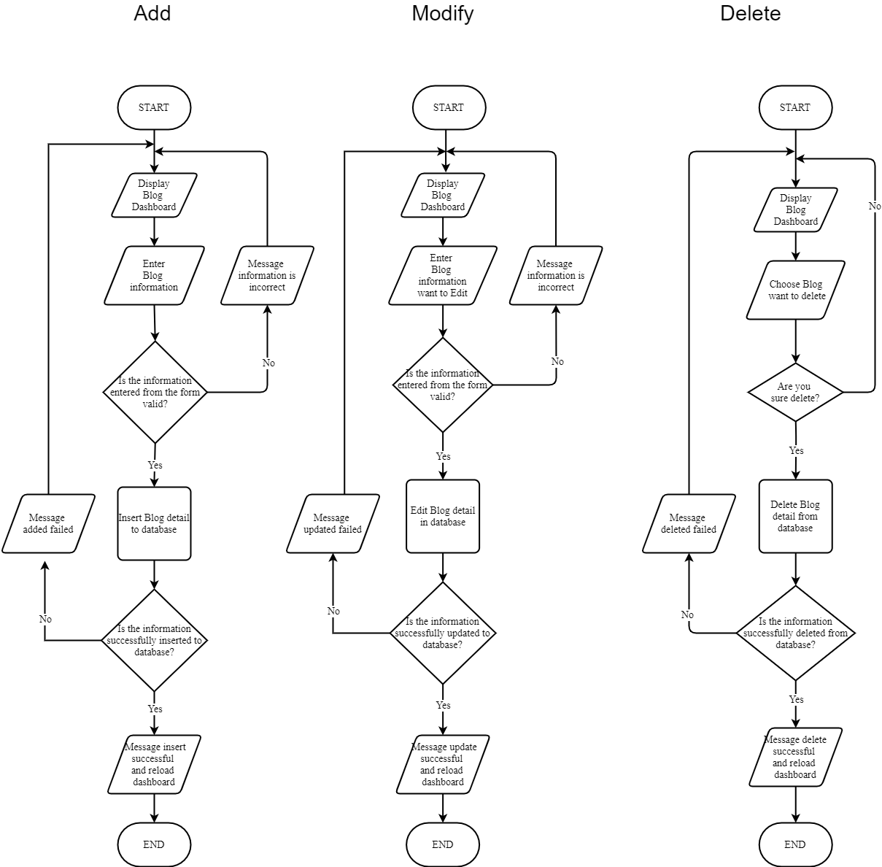

* 1. Manage Sale

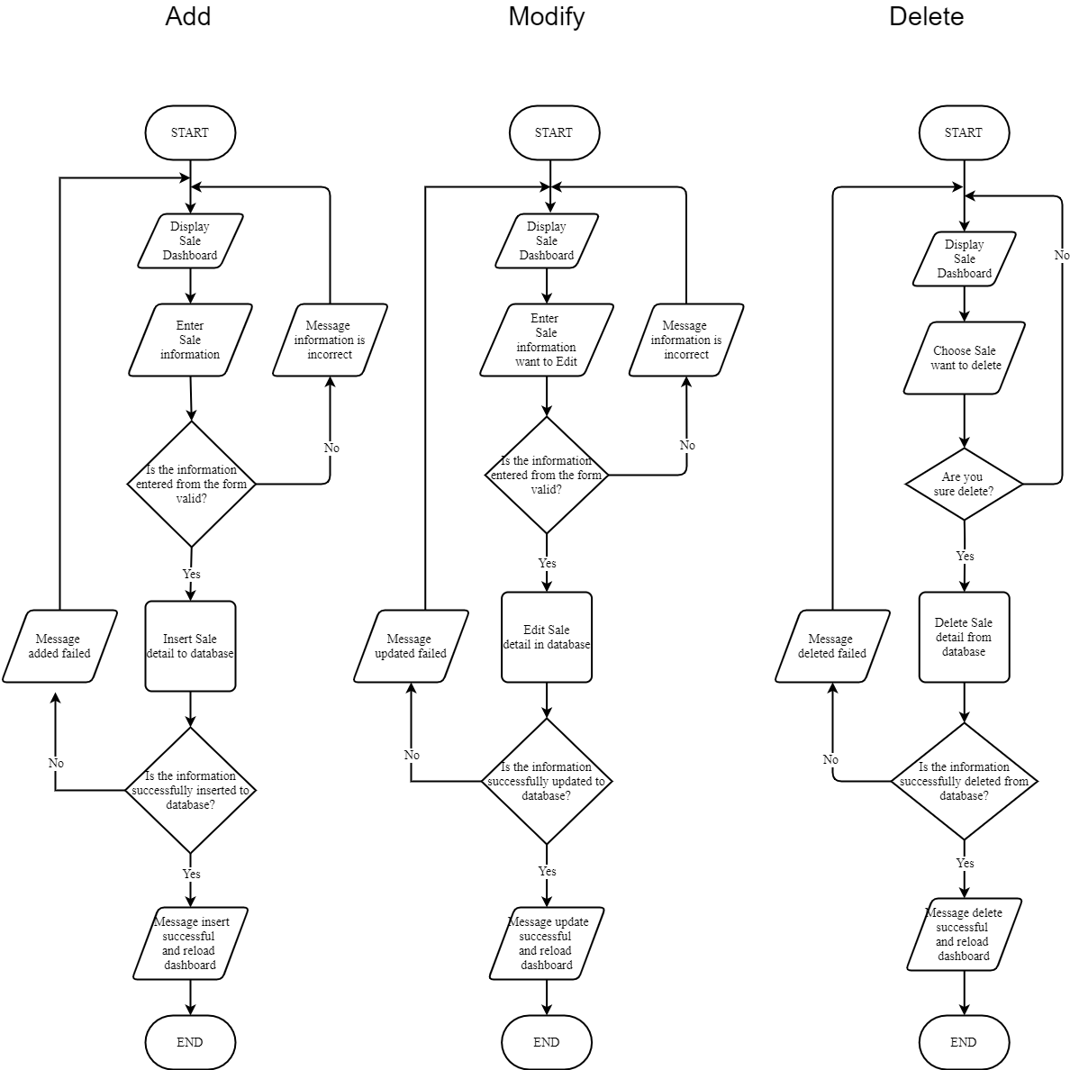

**\* Database design/Structure**

**Table Design:**

|  |  |  |  |  |
| --- | --- | --- | --- | --- |
| **Table: Employees** | | | | |
| **Field Name** | **Data Type** | **Null** | **Key** | **Description** |
| Username | varchar(50) | NO | PK | Store identification of employees who log into the system. |
| Password | varchar(255) | NO |  | Stores the password. |
| FirstName | nvarchar(50) | NO |  | The employee's first name. |
| LastName | nvarchar(50) | NO |  | The employee's last name. |
| DateOfBirth | date | NO |  | The employee's date of birth. |
| Gender | bit | NO |  | Employee gender. |
| Phone | varchar(15) | NO |  | Contact phone number of the employee. |
| Email | varchar(50) | NO |  |  |
| Address | nvarchar(255) | NO |  | The address of the employee. |
| Picture | varchar(500) | YES |  |  |
| Role | int | NO |  | The role of the employee. |
| Status | bit | NO |  | Employee status. |

|  |  |  |  |  |
| --- | --- | --- | --- | --- |
| **Table: Customers** | | | | |
| **Field Name** | **Data Type** | **Null** | **Key** | **Description** |
| Username | varchar(50) | NO | PK | Store identification of employees who log into the system. |
| Password | nvarchar(255) | NO |  | Stores the password. |
| FirstName | nvarchar(50) | NO |  | The customer's first name |
| LastName | nvarchar(50) | NO |  | The customer's last name. |
| DateOfBirth | date | NO |  | The customer's date of birth. |
| Gender | bit | NO |  | The gender of the customer |
| Phone | varchar(15) | NO |  | Contact phone number of the customer. |
| Email | varchar(50) | NO |  |  |
| Address | nvarchar(255) | NO |  | The address of the customer. |
| Picture | varchar(500) | YES |  |  |
| Status | bit | NO |  | Customer status |

|  |  |  |  |  |
| --- | --- | --- | --- | --- |
| **Table: Suppliers** | | | | |
| **Field Name** | **Data Type** | **Null** | **Key** | **Description** |
| SupplierID | int | NO | PK | Store the flower supplier's code. Code is unique. |
| SupplierName | nvarchar(255) | NO |  | The name of the flower supplier |
| ContactName | nvarchar(50) | NO |  | Supplier contact name |
| Phone | varchar(15) | NO |  | Store phone number of contacts |
| Email | varchar(30) | NO |  | Store the email |
| Address | nvarchar(255) | NO |  | Address storage |

|  |  |  |  |  |
| --- | --- | --- | --- | --- |
| **Table: Flowers** | | | | |
| **Field Name** | **Data Type** | **Null** | **Key** | **Description** |
| FlowerID | int | NO | PK | Stores the code of the flower. The code is unique |
| FlowerName | nvarchar(255) | NO |  | Stores flower names |
| Picture | nvarchar(500) |  |  |  |
| ShortDescription | nvarchar(1000) | NO |  | Store a short description of the flower |
| Meaning | text | NO |  | Storing flower meanings |

|  |  |  |  |  |
| --- | --- | --- | --- | --- |
| **Table: Sales** | | | | |
| **Field Name** | **Data Type** | **Null** | **Key** | **Description** |
| SaleID | int | NO | PK | Stores the sale id of the flower. Sale id is unique |
| SaleName | nvarchar(255) | NO |  | Promotional name storage |
| Content | nvarchar(255) | NO |  | Promotional content storage |
| StartDate | datetime | NO |  | Stores the promotion's start date |
| EndDate | datetime | NO |  | Stores the promotion's end date |
| Picture | nvarchar(500) | NO |  | Store pictures of promotion |
| Discount | decimal(12,2) | NO |  | Store on promotional discounts |

|  |  |  |  |  |
| --- | --- | --- | --- | --- |
| **Table: Occasions** | | | | |
| **Field Name** | **Data Type** | **Null** | **Key** | **Description** |
| OccasionID | int | NO | PK | Stores the occasion id of the flower. Occasion id is unique |
| OccasionName | nvarchar(50) | NO |  | Storing the name of the occasion |

|  |  |  |  |  |
| --- | --- | --- | --- | --- |
| **Table: Messages** | | | | |
| **Field Name** | **Data Type** | **Null** | **Key** | **Description** |
| MessageID | int | NO | PK | Stores the occasion id of the flower. Occasion id is unique |
| OccasionID | int | NO | FK | Stores the occasion id created by the Occasion |
| MessageContent | text | NO |  | Stores the content of the message |

|  |  |  |  |  |
| --- | --- | --- | --- | --- |
| **Table: Bouquets** | | | | |
| **Field Name** | **Data Type** | **Null** | **Key** | **Description** |
| BouquetID | int | NO | PK | Stores the bouquet id of the bouquet. bouquet id is unique |
| BouquetName | nvarchar(100) | NO |  | Store the names of the bouquets |
| FlowerID | int | NO | FK | Stores the flower id created by the flower |
| OccasionID | int | NO | FK | Stores the occasion id created by the occasion |
| SaleID | int | NO | FK | Stores the sale id created by the sale |
| MainImage | nvarchar(500) | NO |  | Store pictures of bouquets |
| UnitPrice | int | NO |  | Store pictures of bouquets |
| OldUnitPrice | int | NO |  | Store old prices of bouquets |
| ShortDescription | nvarchar(1000) | NO |  | Store short descriptions of the bouquet |
| Description | text | NO |  | Store descriptions of the bouquet |
| Quantity | int | YES |  | Store the number of bouquets |
| Status | bit | NO |  | Store the number of bouquets |

|  |  |  |  |  |
| --- | --- | --- | --- | --- |
| **Table:** **BouquetImages** | | | | |
| **Field Name** | **Data Type** | **Null** | **Key** | **Description** |
| ImageID | int | NO | PK | Stores the image id of the bouquet images. image id is unique |
| BouquetID | int | NO | FK | Stores the bouquet id created by the bouquet |
| ImageFileName | nvarchar(500) | NO |  |  |

|  |  |  |  |  |
| --- | --- | --- | --- | --- |
| **Table: Bouquet Details** | | | | |
| **Field Name** | **Data Type** | **Null** | **Key** | **Description** |
| FlowerID | int | NO | PK |  |
| BouquetID | int | NO | FK |  |
| Quantity | int | NO |  |  |

|  |  |  |  |  |
| --- | --- | --- | --- | --- |
| **Table:** **Payments** | | | | |
| **Field Name** | **Data Type** | **Null** | **Key** | **Description** |
| PaymentID | int | NO | PK |  |
| PaymentName | nvarchar(255) | NO |  |  |

|  |  |  |  |  |
| --- | --- | --- | --- | --- |
| **Table: Order** | | | | |
| **Field Name** | **Data Type** | **Null** | **Key** | **Description** |
| OrderID | int | NO | PK |  |
| Username | varchar(50) | NO | FK |  |
| PaymentID | int | NO | FK |  |
| Message | text | NO |  |  |
| CreationDate | datetime | NO |  |  |
| Recipient | nvarchar(50) | NO |  |  |
| Address | nvarchar(255) | NO |  |  |
| Phone | nvarchar(15) | NO |  |  |
| ShippingDate | datetime | NO |  |  |
| Note | nvarchar(255) | YES |  |  |
| Status | int |  |  |  |

|  |  |  |  |  |
| --- | --- | --- | --- | --- |
| **Table:** **OrderDetails** | | | | |
| **Field Name** | **Data Type** | **Null** | **Key** | **Description** |
| OrderID | int | NO | FK |  |
| BouquetID | int | NO | FK |  |
| UnitPrice | int | NO |  |  |
| Quantity | int | NO |  |  |

|  |  |  |  |  |
| --- | --- | --- | --- | --- |
| **Table:** Comments | | | | |
| **Field Name** | **Data Type** | **Null** | **Key** | **Description** |
| CommentID | int | NO | PK |  |
| BouquetID | int | NO | FK |  |
| Username | varchar(50) | NO | FK |  |
| Content | text | NO |  |  |
| CommentDate | datetime | NO |  |  |

|  |  |  |  |  |
| --- | --- | --- | --- | --- |
| **Table:** **BlogCategories** | | | | |
| **Field Name** | **Data Type** | **Null** | **Key** | **Description** |
| BlogCategoriesID | int | NO | PK |  |
| BlogCategoriesName | nvarchar(255) | NO |  |  |

|  |  |  |  |  |
| --- | --- | --- | --- | --- |
| **Table:** **Blogs** | | | | |
| **Field Name** | **Data Type** | **Null** | **Key** | **Description** |
| BlogID | int | NO | PK |  |
| BlogName | nvarchar(500) | NO |  |  |
| EmployeeID | varchar(50) | NO | FK |  |
| BlogCategoriesID | int | NO | FK |  |
| Content | text | NO |  |  |
| Date | datetime | NO |  |  |
| Picture | nvarchar(500) | NO |  |  |

|  |  |  |  |  |
| --- | --- | --- | --- | --- |
| **Table:** **BlogComments** | | | | |
| **Field Name** | **Data Type** | **Null** | **Key** | **Description** |
| BlogComent ID | int | NO | PK |  |
| BlogID | int | NO | FK |  |
| CustomerID | varchar(50) | NO | FK |  |
| Content | text | NO |  |  |
| Date | datetime | NO |  |  |

**Task Sheet:**

|  |  |  |  |  |  |  |  |
| --- | --- | --- | --- | --- | --- | --- | --- |
| **Project Ref. No.:** | | **Project Title:** | **Activity Plan Prepared By:** | **Date of Preparation of Activity Plan** | | | |
| **Sr.No** | **Task** | **Actual Start Date** | **Actual Days** | **Team Mate Names** | **Status** |
| 1 | - Form 1:Problem Definition.  - Form 2:  + Business/Project Objective.  + Inputs to the System.  + Output to the System.  + List of Deliverables  + Search for templates.  + Architecture and Design of the Project.  + ER  + Table Design  + DFD:  Employee,  Bouquet,  Flower,  Occasion,  Flower type  +Flow charts:  Employee,  Bouquet,  Flower,  Occasion,  Flower type  + Website  Manage Bouquet,  Blog,  Bouquet Image,  Import, export bouquet,  Employee, Customer, Profile, order  +Client:  Cart , profile, login, change password, My order, search, home page, Blog  + Installation Guide: | Online floral delivery | Tran Ngoc Nguyen | 04/10/2020 | 27 | Tran Ngoc Nguyen | 100% |
| 2 | - Form 2:  + Hardware requirements.  + Software Requirements.  + Search for templates .  + Architecture and Design of the Project.  + DFD  Sale,  Blog,  Bouquet Image,  Supplier  +Flow charts  Sale,  Blog,  Bouquet Image  + Task Sheet  + Check list validatetion  +Submit check list  +Admin:  Manage Blog coment, blog categories, Flower,Supplier  + Client:  Occasion,  Bouquet Detail, | 04/10/2020 | 27 | Tran Mot Em | 97% |
| 3 | - Form 2:  + Process Involved in the System.  + Scope of the Work.  + Architecture and Design of the Project.  +DFD  Payment,  Order  +Flow Charts  Supplier  Payment,  Order  +Submit check list  +Admin  Manage Sale, Occasion  +Client:  Meaning lower | 04/10/2020 | 27 | Quang Tan Dat | 94% |
| 4 | - Form 2:  + Inputs to the System.  + Output to the System.  + Search for templates.  + Architecture and Design of the Project.  + DFD  BlogCategories,  Message  + Flow Charts:  Supplier,  BlogCategories,  Message  +Submit check list  +Admin:  Manage Message, Payment  +Client:  Contact | 04/10/2020 | 27 | Vo Hien Loc | 92% |

**\* Checklist of Validation:**

|  |  |
| --- | --- |
| **Option** | **Validated** |
| Is the GUI design consistent all over? | Yes |
| Features and functionality meet common user goals and objectives. | Yes |
| Call to actions (e.g. register, add to basket, submit) are clear, well labelled and appear clickable. | Yes |
| The Homepage / starting page provides a clear snapshot and overview of the content, features and functionality available. | Yes |
| The home page / starting page is effective in orienting and directing users to their desired information and tasks. | Yes |
| The navigational scheme (e.g. menu) is easy to find, intuitive and consistent. | Yes |
| The navigation has sufficient flexibility to allow users to navigate by their desired means (e.g. searching, browse by type, browse by name, most recent etc…). | Yes |
| The site or application structure is clear, easily understood and addresses common user goals. | Yes |
| Links are clear, descriptive and and well labelled. | Yes |
| Browser standard functions (e.g. 'back', 'forward', 'bookmark') are supported. | Yes |
| Users can easily get back to the homepage or a relevant start point. | Yes |
| The search interface is appropriate to meet user goals (e.g. multi-parameter, prioritised results, filtering search results). | Yes |
| Search results are relevant, comprehensive, precise, and well displayed | Yes |
| Users can easily undo, go back and change or cancel actions; or are at least given the chance to confirm an action before commiting (e.g. before placing an order). | Yes |
| Users can easily give feedback (e.g. via email or an online feedback / contact us form). | Yes |
| Complex forms and processes are broken up into readily understood steps and sections. Where a process is used a progress indicator is present with clear numbers or named stages. | Yes |
| Required and optional form fields are clearly indicated. | Yes |
| Appropriate input fields (e.g. calendar for date selection, drop down for selection) are used and required formats are indicated. | Yes |
| Help and instructions (e.g. examples, information required) are provided where necessary. | Yes |
| Errors are clear, easily identifiable and appear in appropriate location (e.g. adjacent to data entry field, adjacent to form, etc.). | Yes |
| Common user errors (e.g. missing fields, invalid formats, invalid selections) have been taken into consideration and where possible prevented. | Yes |
| Users are able to easily recover (i.e. not have to start again) from errors. | …… |
| Content available (e.g. text, images, video) is appropriate and sufficiently relevant, and detailed to meet user goals. | Yes |
| Language, terminology and tone used is appropriate and readily understood by the target audience. | Yes |
| Terms, language and tone used are consitent (e.g. the same term is used throughout). | Yes |
| Text and content is legible and scanable, with good typography and visual contrast. | Yes |
| Online help is concise, easy to read and written in easy to understand language. | Yes |
| Users can easily get further help (e.g. telephone or email address). | Yes |
| Site or application performance doesn't inhibit the user experience (e.g. slow page downloads, long delays). | Yes |
| Errors and reliabilty issues don't inhibit the user experience. | Yes |

**\* Submission Checklist**

|  |  |  |  |  |  |
| --- | --- | --- | --- | --- | --- |
| **Sr. No.** | **Particulars** | **Yes** | **No** | **NA** | **Comments** |
| 1. | Are all the users able to search for a particular record? | Yes |  |  |  |
| 2. | Are all the old records property saved and retrieved when required? | Yes |  |  |  |
| 3. | Have all the modules been property integrated and are completely functional? | Yes |  |  |  |
| 4. | Are the GUI contents devoid of spelling mistakes? | Yes |  |  |  |
| 5. | Is the application user-friendly? | Yes |  |  |  |
| 6. | Is the project published property into a setup file? | Yes |  |  |  |

*Installation Guide:

# Step 1: Install SQL Server 2017 on the local system (<https://www.microsoft.com/en-us/download/details.aspx?id=55994>)

# Step 2: (Have 2 method)

* Method 1: Attach database to the System
* 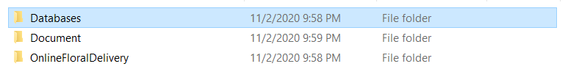After extracting the .zip file. Open the “*Database*” folder
* 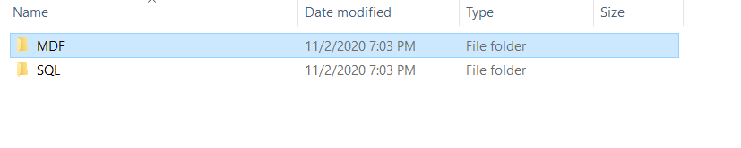Open the MDF folder
* 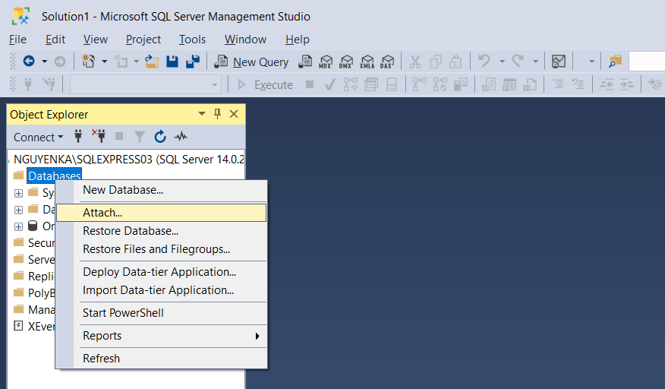Open Microsoft SQL Server Management Studio. Right click on the “Databases” and select “Attach”.
* 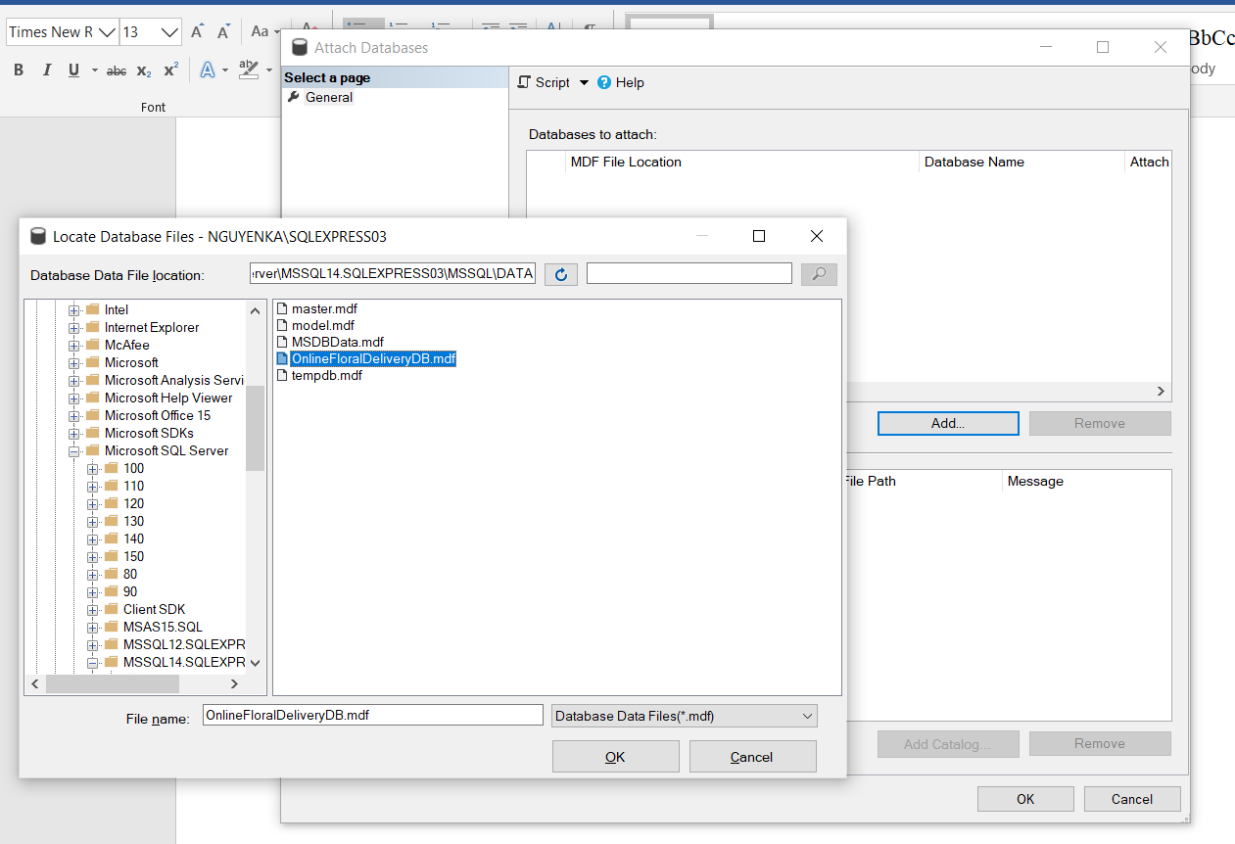Click “Add” and select the path to the directory where the .mdf file is saved. Next, click “OK” and “OK”.
* Method 2: Excute .sql file
* After extracting the .zip file. Open the “*Database*” folder
* Open the SQL folder.
* 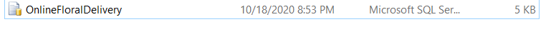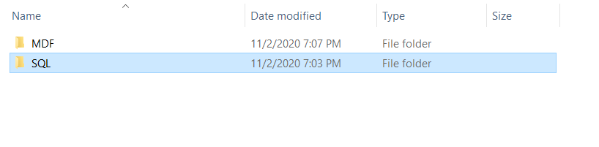Open .sql file by Microsoft SQL Server Management Studio.
* Click “Execute” or press F5 from the keyboard.

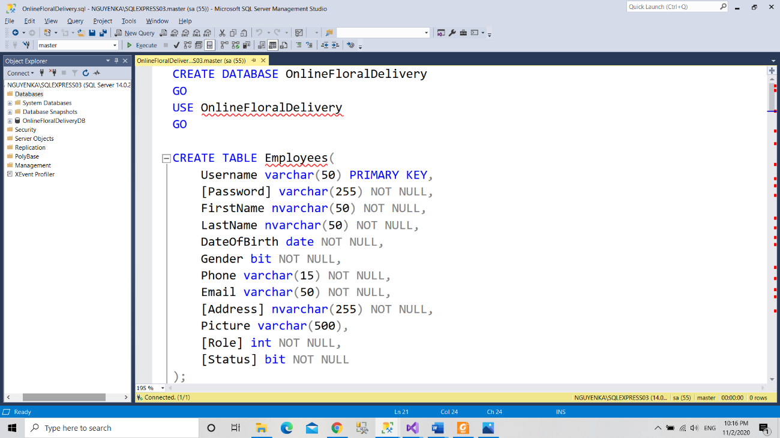

# Step 3: Open project

* Open “*OnlineFloralDelivery*” folder.

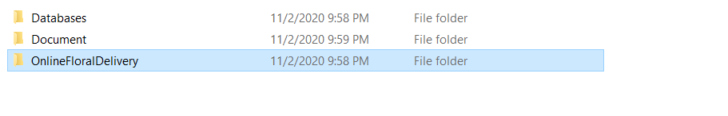

* Open “*OnlineFloralDelivery.sln*” file with Visual Studio 2017.



* Open “*Web.config*” file. Configured in accordance with your computer's SQL server account. In <connectionStrings> </connectionStrings> tag

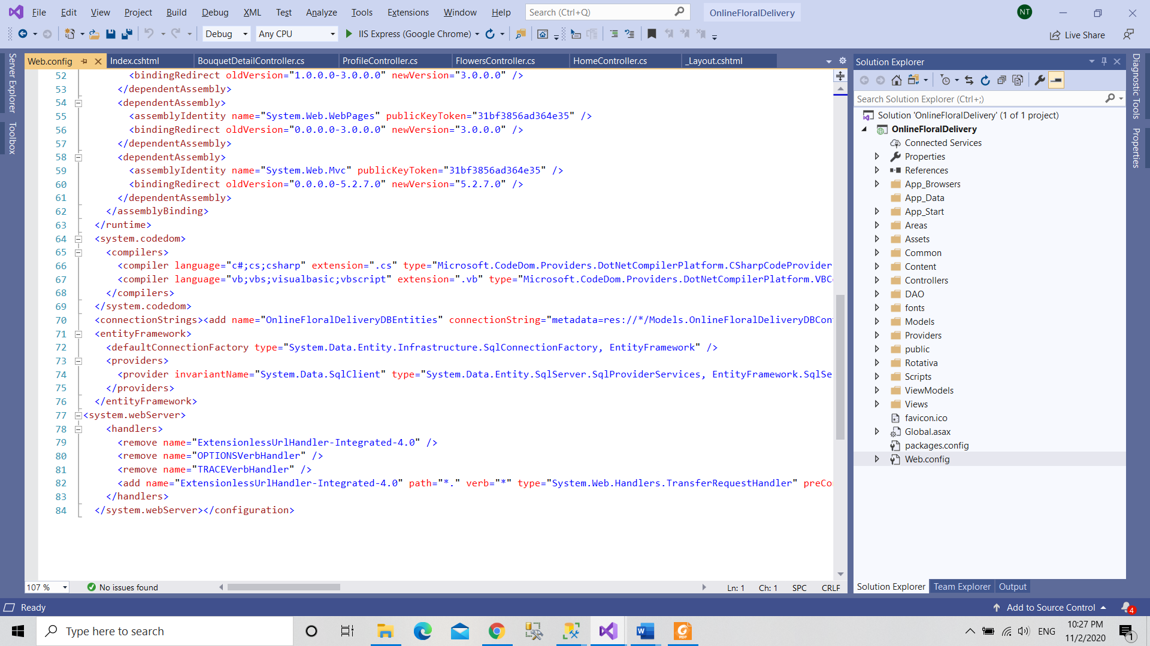

* Example: In <add> tag

data source=.;initial catalog= OnlineFloralDeliveryDB;user id=sa;password=sa

* Click “Save”.
* And “Run” the project.

*User guide

- Home page:

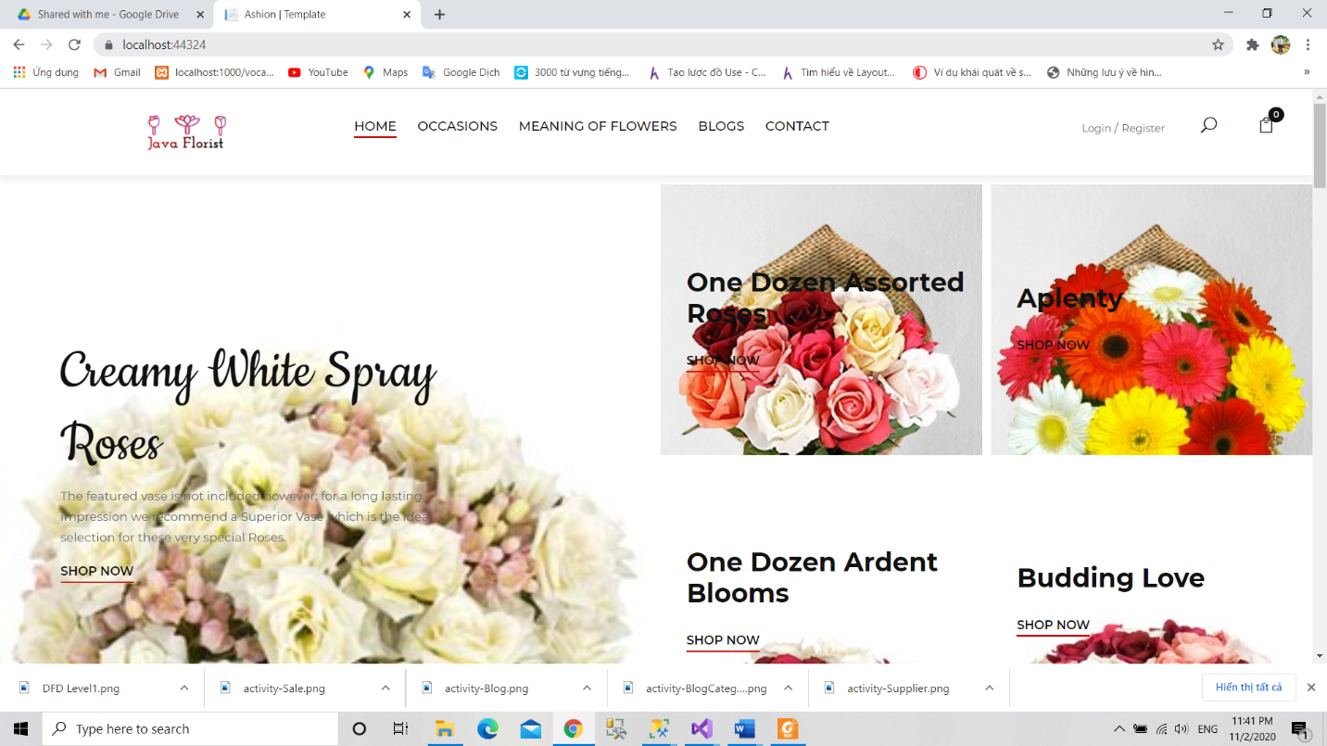

* Login:

+ Client: nguyenka – 12341234

+ Admin: nguyenhandsome – 12345678 (Login 2 time)

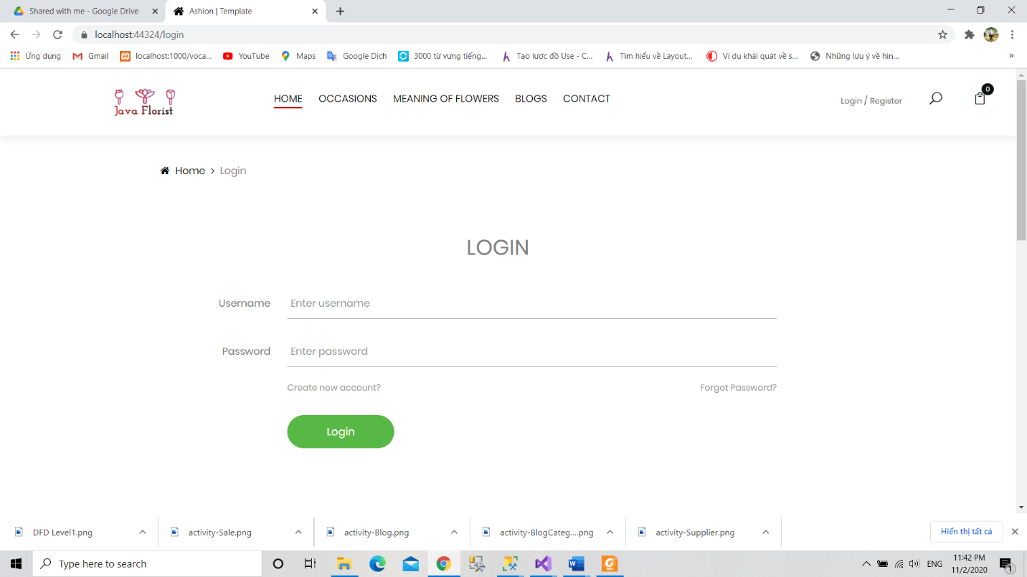

* Cart:

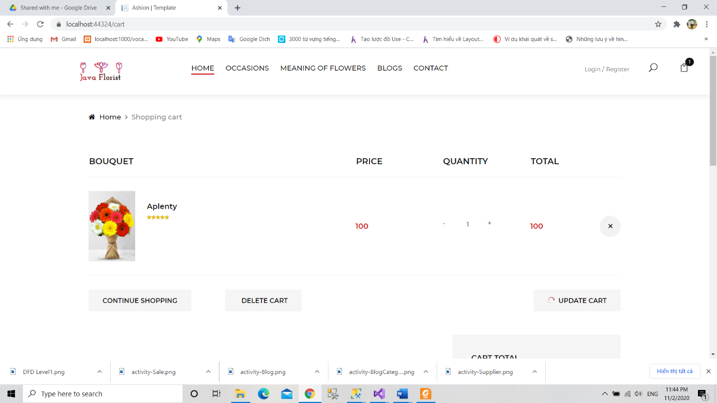

* My order:
* 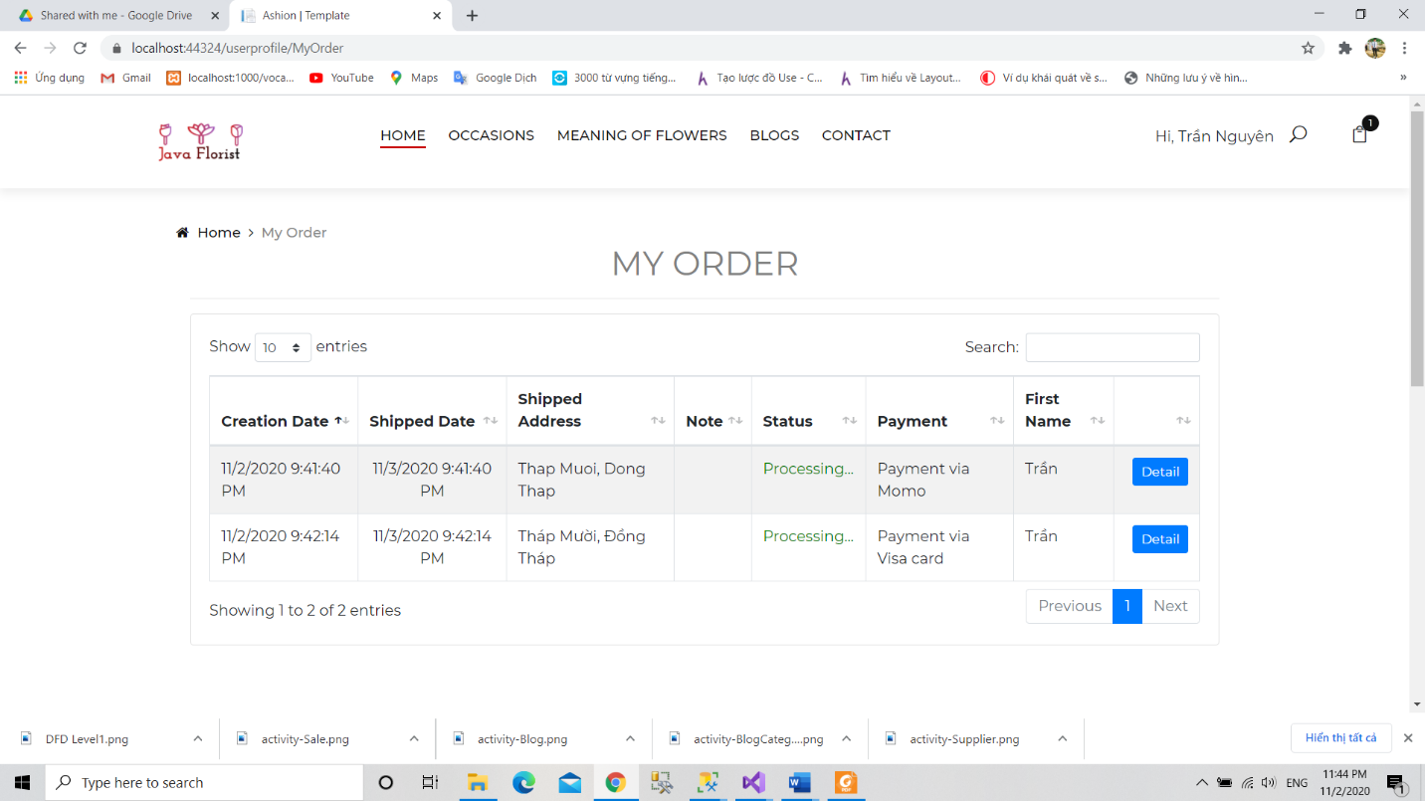Change Password:

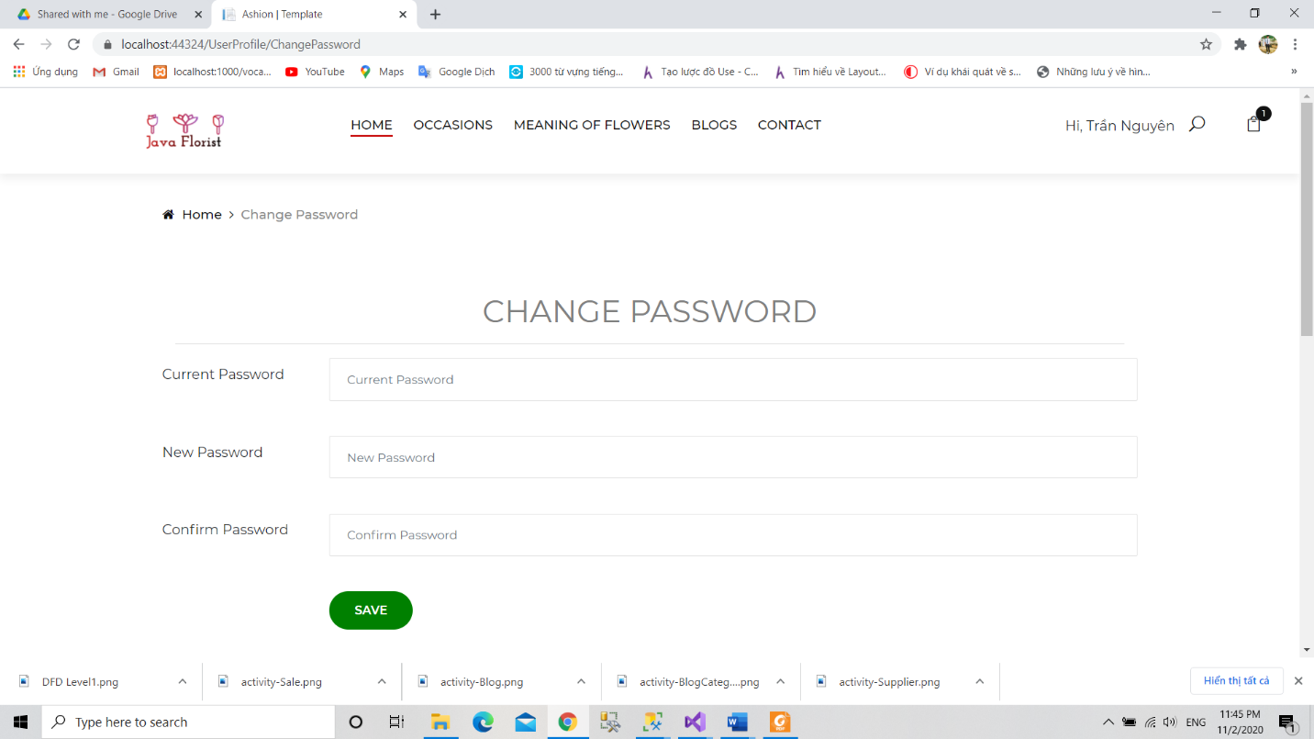

Admin:

+ Profile:

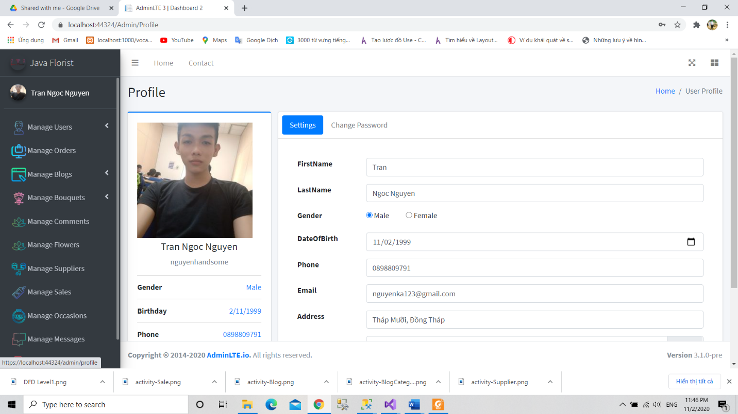

+ Mange Enployee:

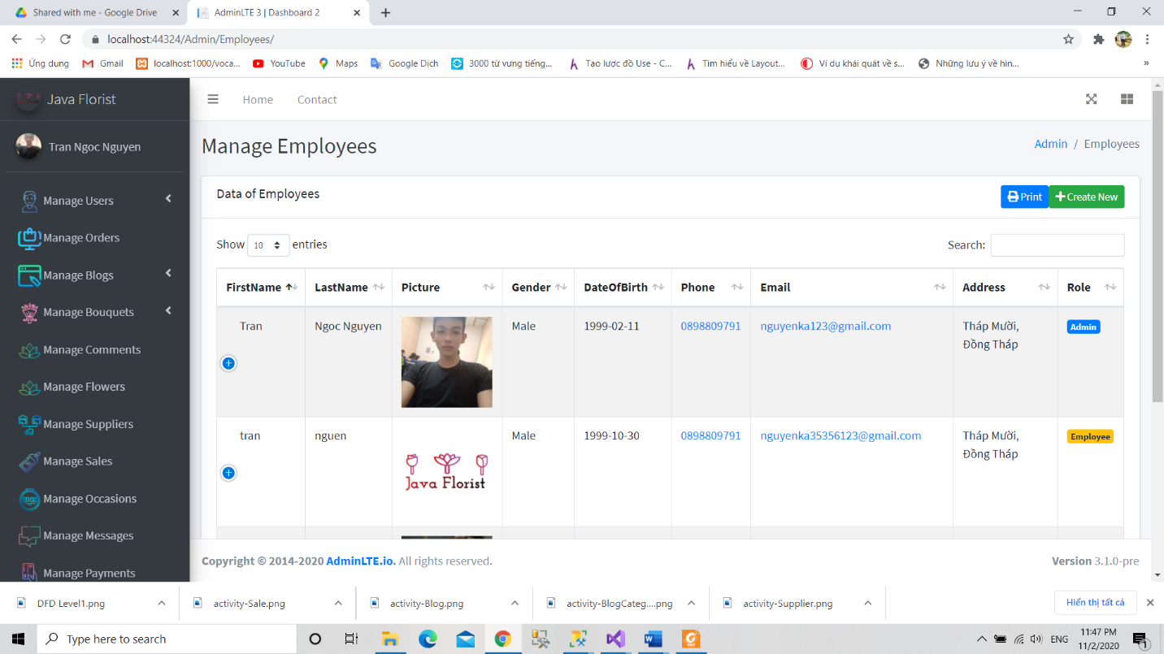

+ Customer:

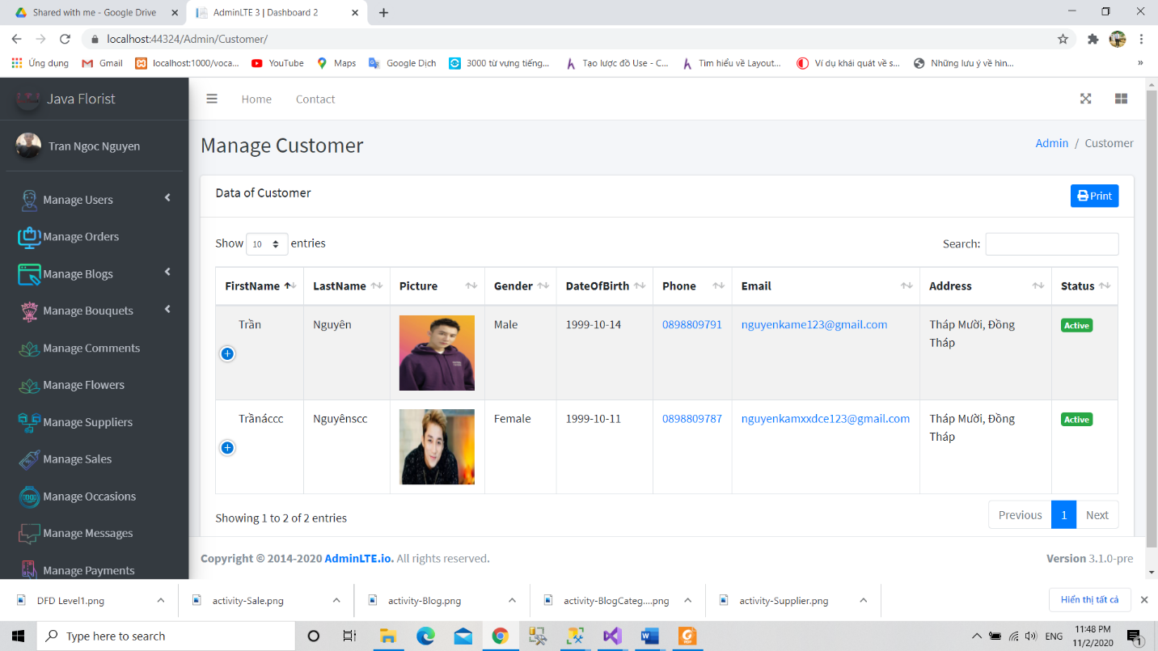

+ Add bouquet

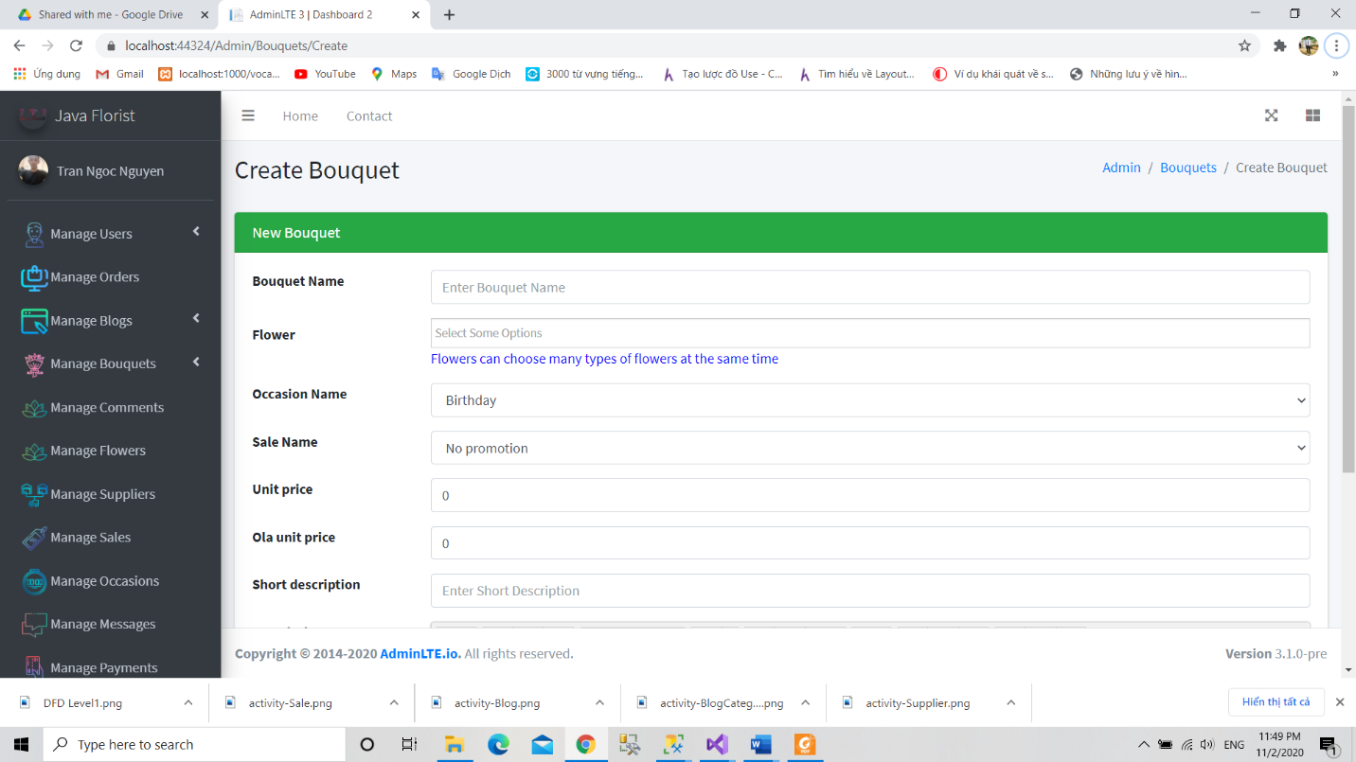

+ Import stock:

